# **Unit 1**

**ECOLOGY**

(a) (i) IDENTIFY ANY 5 FAUNA AND ANY FIVE FLORA USING SIMPLE KEYS (ii) IDENTIFY A VARIETY OF HABITATS WITHIN THE SELECTED ECOSYSTEM

## **MATERIALS/EQUIPMENT**

Identification keys

**PROCEDURE**

1. I used a key consisting of a series of questions relating to the organism I was trying to identify
2. I answered ‘yes’ or ‘no’ to pairs of questions relating to the selected organism
3. I then looked to the right of the set of questions, and using the number indicated, moved down to the correct set of alternatives.
4. I continued to do this until a name was reached.
5. I noted the habitat of the organism.
6. I repeated this procedure to identify 5 flora and 5 fauna.
7. I recorded my results.

## **RESULT**

|  |  |  |
| --- | --- | --- |
| Organism name | **Habitat** | **Adaptation feature** |
| Crab | Under rock – lower shore | Hard shell - protection |
| Bladder wrack | Attached to rocks –middle shore | Air bladders – buoyancy for photosynthesis |

(b) IDENTIFY AND USE VARIOUS APPARATUS REQUIRED FOR COLLECTION METHODS IN AN ECOLOGICAL STUDY

**DIAGRAM**

**MATERIALS**

**PROCEDURE**

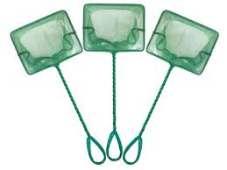

1. I used a fish net to catch butterfish by sweeping the net through the water.
2. I used a cryptozoic trap and forceps to catch small crabs.
3. I used a plankton net to collect microscopic plants and animals



Fish net

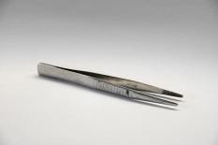Forceps

Plankton net

Fish

net

Forceps

Plankton net

(c) CONDUCT A QUANTITATIVE STUDY OF PLANTS AND ANIMALS OF A SAMPLE AREA OF THE SELECTED ECOSYSTEM

**EQUIPMENT**

**Procedure (% Frequency)**

1. I threw a quadrat randomly in the sample area of the selected ecosystem. I first threw a pencil over my shoulder and placed the quadrat where it landed.
2. I recorded the presence or absence of the named plants and animals within each quadrat.
3. I repeated for a number of throws
4. I counted the total number of times the named organisms were present.
5. I calculated the frequency.
6. I recorded my results

**DIAGRAM**

Quadrat

## 

**Quadrat**

## **RESULT**

# 

Frequency = No. of quadrats containing organism

No. of quadrats thrown

If percent is required multiply frequency by 100

(d) (i) INVESTIGATE ANY THREE ABIOTIC FACTORS PRESENT IN THE SELECTED ECOSYSTEM, AS LISTED

(ii) RELATE RESULTS TO CHOICE OF HABITAT SELECTED BY EACH ORGANISM IDENTIFIED IN THIS STUDY

**DIAGRAM**

**MATERIALS/EQUIPMENT**

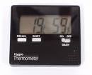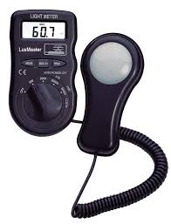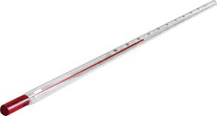Thermometer

Digital Hygrometer

Digital Light meter

Light meter

Thermometer

Hygrometer

## **PROCEDURE**

1. I choose three abiotic factors present in my selected ecosystem to measure e.g. temperature, humidity and light intensity.
2. I placed the thermometer in the habitat of the identified organism.
3. I switched on the hygrometer and light meter and placed them in the habitat of the identified organism.
4. I recorded my results.

|  |  |  |  |  |
| --- | --- | --- | --- | --- |
|  | | **Abiotic factors and measurements** | | |
| **Organism Name** | **Suitability of Habitat** | **Temperature (0C)** | **Humidity (%)** | **Light Intensity (Lux)** |
| **Lichen** | **Yes** | 12 | 70 | 1005 |
|  |  |  |  |  |

**RESULTS**

**(e) CONSTRUCT A (i) FOOD CHAIN, (ii) A FOOD WEB AND (iii) A PYRAMID OF NUMBERS**

(i) **FOOD CHAIN**

**Seaweed Shrimp Sea anemone Gull**

(ii) **FOOD WEB**

Algae

Periwinkle

Crab

Shrimp

Mussels

Limpet

Plankton

Sea Anenome

Goby

Dog Whelk

Sea Slug

Gull

# **(iii) PYRAMID OF NUMBERS**

Seaweed

Shrimp

Sea anenome

Gull