Scientific Method and Areas of Biology
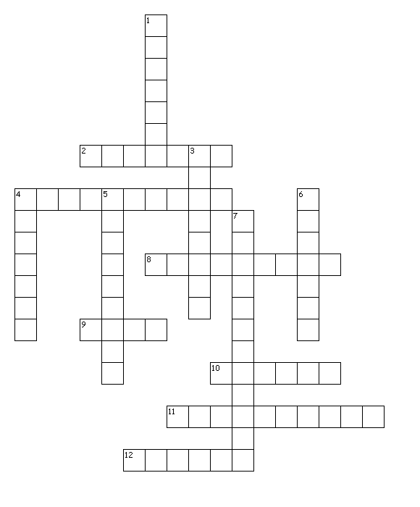
Down
1. A comparison for an experiment
3. The study of inheritance
4. The study of interactions between organisms and their environment
5. A repeat of an experiment
6. The study of living things
7. The study of microorganisms

Across
2. The study of animals
4. A test of a hypothesis
8. A theory which has stood the test of time
9. Information collected during an experiment
10. The study of plants
11. An educated guess
12. A supported hypothesis

