- Indicate whether the following statements are true or false by placing a tick () in the appropriate box in
each case.
True | False

  - Meiosis is an important source of variation.
  - Mitosis occurs in mature red blood cells in humans.
  - During mitosis the nuclear membrane temporarily disappears.
  - Meiosis gives rise to the haploid condition.
  - In multicellular organisms mitosis functions primarily in growth.
  - In plants, a cell plate forms during telophase of mitosis.
  - The human zygote divides by meiosis.

- In an experiment, a student cut some potatoes into small, evenly-shaped pieces.
She divided them into groups of 10, weighed each group and placed them in sucrose solutions of different concentration, labelled A to F. Two hours later, she removed the potato pieces from the sucrose solutions, dried them and reweighed them. She plotted her results on a graph (change in mass versus % sucrose solution). The graph is shown below.

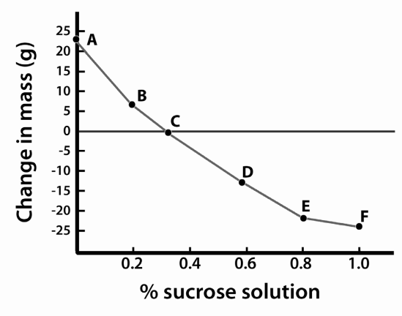
  - From the graph, determine the concentration of the contents of the potato cells.

  - Explain in detail why the pieces in solutions D to F lost mass.

  - Give one example of the use of the mechanism(s) described in (b) in food preservation.

  - Explain how plant cells remain turgid.

