Qualitative test for FAT

CHEMICALS /MATERIALS

Vegetable oil

Brown paper

Water
DIAGRAM
PROCEDURE
- I placed a drop of oil on one piece
of brown paper
- I placed a drop of water on the other
piece of paper. This acted as a control.
- I left both aside to dry.
- I held both pieces up to the light.
- I recorded my result.

RESULT

Sample | Presence of Translucent spot
 | Before drying | After drying
Oil | No | Yes
Water | No | No

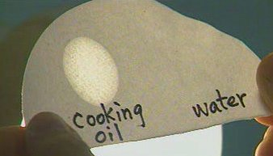
Test for Fat
Fat + Brown paper = Translucent spot

