BE FAMILIAR WITH AND USE THE LIGHT MICROSCOPE
Answer the following:

- Aim:
State the aim of this experiment:
__________________________________________________________________________________________________________________________________________________________
- Background:
(a) Name one other type of microscope: _______________
(b) State one advantage of the microscope you have named:
__________________________________________________________________
- Apparatus:
- Name the parts labelled 1-9 on the diagram of the light microscope shown below:
1

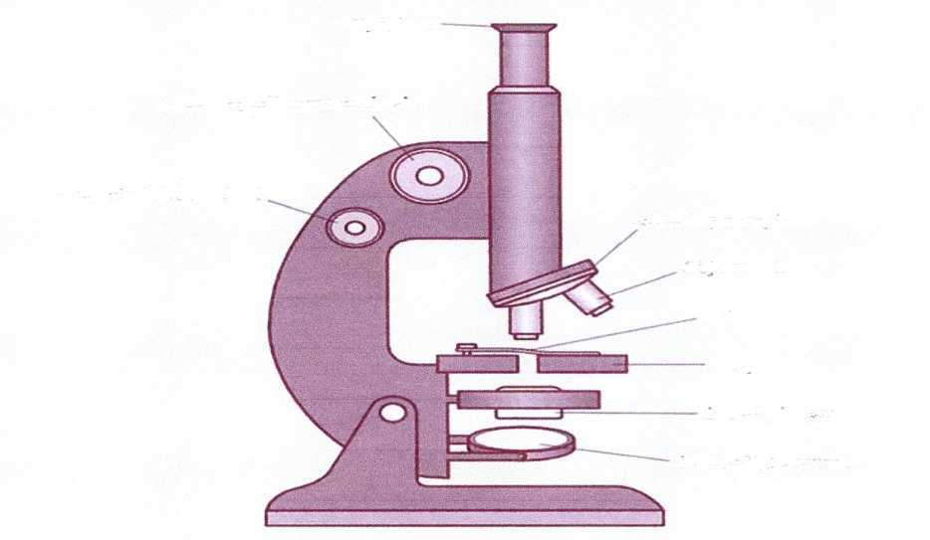
2
4
3
5
6
7
9
8

- Give the function for each of the following parts:
3 = _______________________________________________________________
6 = _______________________________________________________________
9= _______________________________________________________________

- Procedure:
(a) When using the light microscope, which objective lens will you rotate into place first? _____________________________________________________

(b) On which part of the stage will you place the slide?
__________________________________________________________
(c) Why is it important to watch from the side, not the top, while raising the stage to meet the lens?
________________________________________________________________________________________________________________________
(d) If you think that more or less light is required to view the slide what will you do?
________________________________________________________________________________________________________________________
(e) How will you change the magnification?
________________________________________________________________________________________________________________________
(f) How will you calculate the total magnification?
____________________________________________________________
(g) Name two skills you would expect to learn while carrying out this experiment:
(i) ___________________________________________________________
(ii) ____________________________________________________________
(h) State two precautions you should consider before carrying out this experiment:
(i) ____________________________________________
(ii) ___________________________________________
- Application:
State one application of this experiment

