Q 2017 15 b
The vertebral column is part of the human axial skeleton and is composed of bones called vertebrae, with intervertebral discs.

    - There are five regions in the vertebral column. Name any two of these regions and
state how many bones are found in each named region.
    - What are the intervertebral discs made of and what is their function?
    - Bone tissue is continually broken down and reformed during life.
      - Name the cells that break down bone.
      - Name the cells that build bone.
    - Give two factors on which the continued renewal of bone depends.

Q 2016 15 c i
- Long bones contain both yellow marrow and red marrow. Give one function of each type of marrow

MS 2016 15 c i
(i) | Yellow marrow: | Stores fat or converts to red marrow | 3
 | Red marrow: | Produces blood cells | 3

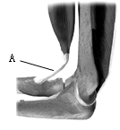
Q 2014 11 a
(i) Name the type of joint shown in the diagram.

- Name the structure labelled A, which attaches muscle to bone.

- Explain what is meant by an antagonistic muscle pair. (9)

MS 2014 11 a

(a) | (i) | *Hinge | 3
 | (ii) | *Tendon | 3
 | (iii) | (A pair of muscles that) work with opposing actions
 |  | or explained. | 3

Q 2012 3
(a) The diagram shows the macroscopic structure of part of a long bone.

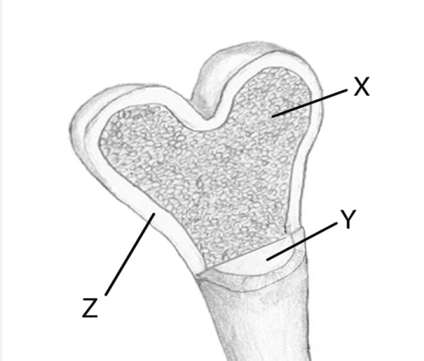

- Name a long bone in the human body.

- Name parts X, Y and Z in the diagram.

 | (iii) | State a function of X.
 | (iv) | State a function of Y.
(b) | (i)  (ii) | Show clearly on the diagram where you would expect to find cartilage.  State one role of this cartilage.

MS 2012 3
3. |  |  | 2(7) + 6(1)
 | (a) | (i) | Name of long bone e.g. femur, tibia, fibula, humerus, radius, ulna
 |  | (ii) | X = spongy bone or marrow; Y = medullary cavity or marrow; Z = compact bone
 |  | (iii) | X: Strength (or rigidity) or lowers density or makes blood cells (or named) or makes marrow
 |  | (iv) | Y: Makes (yellow) marrow or stores fat or makes blood cells (or named)
 | (b) | (i) | Indication of cartilage on diagram
 |  | (ii) | Prevents bone damage or friction free movement or shock absorption

Q 2009 4
- (a) The diagram shows a longitudinal section of a long bone.

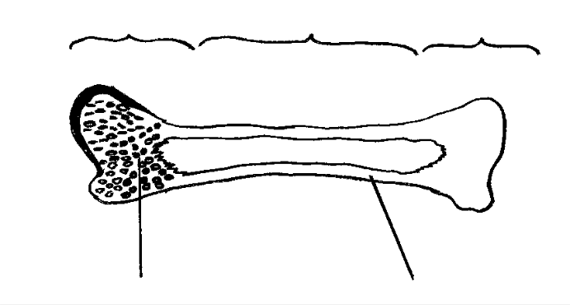
A
B
A
C
D
- Name the parts of the diagram labelled A, B, C, D.

  - B.

C. D.

- Where are the discs in the human backbone?

- What is the function of the discs in the human backbone?

(b) Give a role for each of the following in the human body:

- Yellow bone marrow.

- Red bone marrow.

MS 2009 4
4. | (a) | (i) | A = Head (epiphysis) | 2
 |  |  | B = Shaft (diaphysis) | 2
 |  |  | C = Spongy bone | 2
 |  |  | D = Compact bone | 2
 |  | (ii) | Between the vertebrae | 3
 |  | (iii) | Shock absorption or friction-free movement or prevention of wear and tear | 3
 | (b) | (i) | Fat storage or can convert to red marrow | 3
 |  | (ii) | Blood cell formation | 3

Q 2008 15 a
  - Answer the following questions in relation to the human musculoskeletal system.
    - Give three roles of the skeleton.
    - Explain what is meant by the axial skeleton.
    - Give a function for each of the following:
      - Red marrow, 2. Cartilage, 3. Tendon.
    - Explain what is meant by an antagonistic muscle pair and give an example in the human body.
    - Suggest a treatment for a named disorder of the musculoskeletal system.

MS 2008 15 a
(a) | (i) | support / movement / protection / anchorage for muscle / gives shape / blood production | 3(3)
 | (ii) | vertebral column and skull (and rib cage) | 3
 | (iii) | - formation of blood cells  - protection (absorbs shock) or reduces friction or allows bone elongation  - joins muscle to bone | 3
 |  |  | 3
 |  |  | 3
 | (iv) | pair of muscles that have opposite effects or explained | 3
 |  | biceps and triceps or other example | 3
 | (v) | treatment of named disorder | 3

Q 2006 15 a
- (i) Draw a diagram to show the structure of a synovial joint. Label three
parts of the joint that you have drawn, other than bones.
- Explain the functions of the three parts that you have labelled.
- Name a disorder of the musculoskeletal system.
- Give a possible cause of the disorder that you have named in (iii) and suggest a treatment for it.

MS 2006 15 a
- (i) diagram 6, 3, 0
labels (cartilage, fluid, capsule or membrane, ligament) 3(2)

  - cartilage: absorbs shock or reduces wear or protection
or reduces friction
synovial fluid: friction-free movement or absorbs shock ligaments: hold bones together
synovial membrane or capsule: secretes or contains synovial fluid

 |  | any three | 3(3)
 | (iii)  (iv) | osteoporosis or arthritis  Disorder:  cause: genetic / hormonal / dietary / injury or wear and tear treatment: anti-inflamatory drugs / hormonal or named / dietary supplements / pain killers / muscle relaxants / physiotherapy / exercise | 3  3  3

Q 2005 14 c iii
  - Name a disorder other than cancer for each of the following and indicate a possible cause and a means of treatment:
      - Musculoskeletal system

MS 2005 14 c

(iii)1. Name 3
Arthritis / osteoporosis
Cause 3
Arthritis – injury / hormonal imbalance / genetic /immune response
Osteoporosis- hormonal imbalance / lack of exercise / genetic / dietary /menopause
Treatment 3
arthritis – anti-inflammatory drugs/ analgesics/ rest / exercise/ replacement of joint / steroids or named/ immuno-suppressants
osteoporosis: HRT / exercise / diet / dietary supplements or named

