Movement Through Cell Membranes

Q 2016 14 (c)

(i) 1. What do you understand by the term turgor in plant cells?

- How do plant cells remain turgid for a considerable period of time?

- What happens to a plant if many of its cells lose turgidity?

- If an animal cell were subjected to the conditions that result in a plant cell becoming turgid, suggest what may happen to the animal cell. Explain your answer.

(ii) 1. In relation to the passage of materials through cell membranes, distinguish between
diffusion and osmosis by writing one sentence about each term.

2. In your study of human physiology you encountered an example of active transport. Name the location and a material involved.

MS 2016 14 (c)

14. | (c) | (i) | 1. | Turgor: Pressure of cell contents against the cell wall | 3
 |  |  | 2. | How plant cells stay turgid: By taking in as much water as they lose | 3
 |  |  |  | By osmosis (or explained) | 3
 |  |  | 3. | Consequence for plant of turgidity loss: Wilt or lose rigidity or fail to stay upright  or droop | 3
 |  |  | 4. | Animal cell: Bursts | 3
 |  |  |  | Why: No cell wall | 3
 |  | (ii) | 1 | Diffusion: Movement (of material) from region of high concentration to a
 |  |  |  | region of low(er) concentration | 3
 |  |  |  | Osmosis: Movement of water from a region of high water concentration to a
 |  |  |  | region of low(er) water concentration across a semi-permeable  membrane | 3
 |  |  | 2 | Active transport; location: Nephron or named part | 3
 |  |  |  | Active transport; material: Glucose or amino acid(s) or salt(s) or water | 3

Q 2015 5

- In an experiment, a student cut some potatoes into small, evenly-shaped pieces.
She divided them into groups of 10, weighed each group and placed them in sucrose solutions of different concentration, labelled A to F. Two hours later, she removed the potato pieces from the sucrose solutions, dried them and reweighed them. She plotted her results on a graph (change in mass versus % sucrose solution). The graph is shown below.

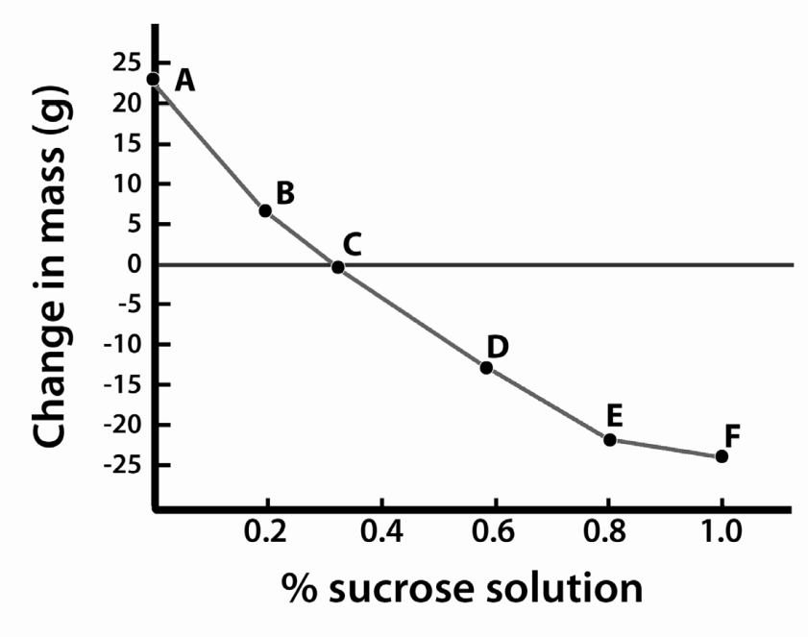

  - From the graph, determine the concentration of the contents of the potato cells.

  - Explain in detail why the pieces in solutions D to F lost mass.

  - Give one example of the use of the mechanism(s) described in (b) in food preservation

  - Explain how plant cells remain turgid.

MS 2015 5

5.
8 + 8 + 4(1)
- (Equivalent to ) 0.3 – 0.35 (% sucrose solution)

- They lost water / by osmosis / because sucrose was more concentrated
Any Two
- Salting (or curing) meat (or fish) or making fruit products such as jam or use of sugar for

(preserving) fruit

- Water taken in / (water) into vacuole (or into cytoplasm) / protoplast (or membrane)
presses against cell wall / wall prevents bursting
Any Two

Q 2013 5 a
(i) In relation to structures such as the cell membrane, explain the term selective permeability.

- Suggest an advantage to the cell of having a selectively permeable membrane

- Name two substances that enter a human muscle cell by diffusion.

(b) (i) Explain the term turgor.

- Give a feature of a plant cell that allows it to remain turgid for long periods.

- Suggest a way in which turgor is of value to plants.

MS 2013 5 a,b

(a) | (i)  (ii) | Only certain substances (or named substances) allowed through  Substances can be kept in (or out) or substances can be let in (or out)
 | (iii) Oxygen / glucose / water / amino acids / phosphate (or P) / iron |  | Any two
(b) | (i) Pressure / of cell contents (or described) / on cell wall |  | Any two
 | (ii) Vacuole or cell wall or cell sap
 | (iii) Support (or described)

Q 2012 15c

(i) Explain the term homeostasis.

- Homeostasis often requires an organism to exchange materials between different tissues, or between itself and the external environment by diffusion, osmosis, and active transport. Explain each of the underlined terms.

MS 2012 15c

15. (c) | (i) | homeostasis: Maintenance of a constant internal environment | 3
 | (ii) | diffusion: movement of substances with (along) a concentration gradient or explained | 3
osmosis: movement of water through a selectively permeable membrane from a high water concentration to a low concentration |  |  | 3
active transport: movement of molecules against a concentration gradient  or movement of molecules using energy |  |  | 3

Q 2011 14 c

  - (i) State the precise location of the cell membrane in plant cells.
- With what type of cell do you associate membrane-bound organelles?
- What corresponding term is used to describe bacterial cells?
- The cell membrane is described as being selectively permeable. What does this mean?
- Why is diffusion alternatively known as passive transport?
- Osmosis may be described as “a special case of diffusion”. Explain why.
- Describe, with the aid of a labelled diagram, how you demonstrated osmosis in the laboratory.
- Name the structure by which Amoeba gets rid of excess water that has entered by osmosis.

MS 2011 14c

(i) | Immediately inside the cell wall | 3
(ii) | *Eukaryotic | 3
(iii) | *Prokaryotic | 3
(iv) | Only some substances are allowed through | 3
(v) | No (or little) energy (or ATP) required | 3
(vi) | Movement of water or (osmosis) requires a membrane | 3
(vii) | Diagram: Container + 2 solutions separated by a membrane | (3,0)
 | Labels: Membrane or plant tissue / solution 1 indicated / solution 2 indicated | 3(1)
 | Result: Shown in diagram or stated | 3
(viii) | Contractile vacuole | 3

Q 2010 14 c

  - (i) In relation to membranes in cells, explain what is meant by selective permeability.
- Give two locations in a cell at which there is a selectively permeable membrane.
- 1. What is diffusion?
2. In the case of a named molecule, give a precise location at which it diffuses in the human body.
- Explain the biological basis for the use of high sugar or high salt concentrations in the preservation of food.

MS 2010 14c

(c) | (i) | Allowing some substances to pass through | 3
 | (ii) | Chloroplast / mitochondrion / nucleus / vacuole  [allow cell membrane]  Any two | 2(3)
 | (iii) | - Movement of molecules (or substances)  from area of high concentration to area of low concentration (or along a concentration gradient)  - Named molecule and location | 3  3  6
 | (iv) | Bacteria / lose water / by osmosis / inactivity or death  Any three | 3(3)

Q 2008 14 c

  - (i) Draw a large labelled diagram of a transverse section through a young root.
- Water enters the outermost cells of the root by osmosis. What does this tell you about the cell sap of these outermost cells?
- Osmosis has been described as a special case of diffusion. Explain why.
- Describe an investigation that you carried out to demonstrate osmosis.
- Describe how minerals such as nitrates enter the root of a plant from the soil.

MS 2008 14 c

(i) | Diagram | 3, 0
 | Labels: dermal tissue, ground tissue, vascular tissue [accept xylem or
 | phloem for vascular] | 3(2)
(ii) | lower water concentration or higher solute concentration | 3
(iii) | movement of water (solvent) / along concentration gradient / through a selectively permeable membrane | 2(3)
(iv) | membrane or plant tissue / 2 solutions indicated  / different concentrations / result | 3(3)
(v) | diffusion or passive transport | 3

