3.3.3 Nutrition in the human
At the end of this section you should be able to …
Define Heterotrophic organisms
Define Omnivore (Human)
Define Herbivore
Define Carnivore
Define Explain the term digestion
Outline the need for digestion and a digestive system.
Explain the terms ingestion, digestion, absorption, egestion as related to the sequence in the human digestive tract.
3.3.4 Human digestive system
At the end of this section you should be able to …
Macrostructure and basic function of the alimentary canal and the associated glands in digestion and transport of nutrients.
Explanation of the chemical breakdown and transport of food, to include the role of teeth, peristalsis, and the stomach.
Explanation of the chemical breakdown of food to include:
Bile salts
The role, production site, pH at a named location of action of an amylase, a protease, and a lipase enzyme.
Two functions of symbiotic bacteria in the digestive tract.
Benefits of fibre.
Basic structure of the small intestine and large intestine in relation to their functions.
3.3.5 Blood Transport of nutrients
At the end of this section you should be able to ..
Describe the composition of blood fluid as a transport system of nutrients,
Describe the absorption of nutrients from the villi,
Describe the transport of nutrients through the hepatic portal vein to the liver.
Describe the functions of the liver (without biochemical pathways).
Describe the transport of nutrients to all nutrient requiring cells of the body,
Describe the transport of waste products to the kidney
3.3.6 Balanced Human Diet
At the end of this section you should be able to …
Explain the concept of a balanced diet, variety and moderation.
Relate the importance of diet to age, sex, activity and variety
Explain the food pyramid

Key Words

carnivore, herbivore, omnivore, ingestion, digestion, absorption, assimilation, egestion, enzymes, villus, peristalsis, duodenum, jejunum, ileum, gastric, saliva, pepsinogen, pepsin, amylase, lipase, lacteal, symbiotic bacteria, liver, pancreas, colon, rectum, anus, balanced diet, bile salts

3.3.3 Nutrition in the human – Summary

- Heterotrophic organisms: Cannot make their own food. Must take in preformed food. e.g all animals, some bacteria.

Heterotrophs can be saprophytic or parasitic.
- Saprophytic: A type of nutrition where organisms feed on dead and decaying organic matter.
- Parasitic: A type of nutrition where organisms live in or on another living organism of a different species, causing it harm.

- Omnivore (Human): An animal which eats both plant and animal material.
- Herbivore: An organism which feeds on plant material only.
- Carnivore: An organism which feeds on animal material only.

- Digestion: Food is broken down into smaller pieces so that it can be absorbed into the blood stream and transported around the body.
- Ingestion: Taking in of food
- Digestion: Food broken down into smaller pieces
- Absorption: Small pieces of food pass from the digestive system into the blood and are transported around the body.
- Egestion: Removal of undigested food from the body as faeces

3.3.4 Human Digestive System - Summary
Functions of parts of the alimentary canal
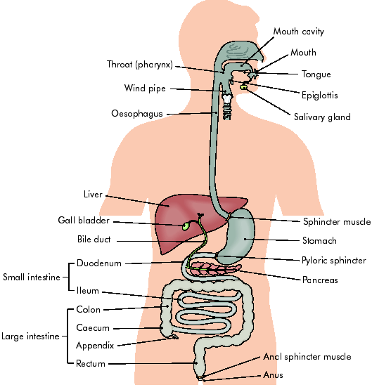
1. Mouth
- Contains a muscular tongue and a set of teeth.
- Chemical ( enzymes) and mechanical (teeth) digestion of food takes place in the mouth
Chemical Digestion: Enzymes.
- Secretes a juice called saliva from the salivary glands.
- Saliva contains an enzyme called amylase.
- Saliva lubricates the food
- Salivary amylase converts Starch to Maltose
- Alkaline pH
Mechanical digestion: teeth

Human Teeth (32)

Types of teeth
Human Dental Formula

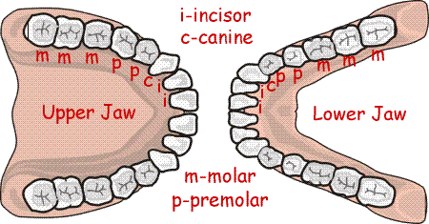
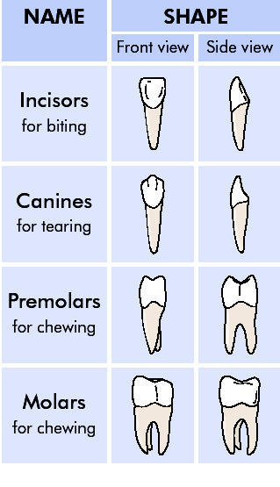
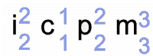

2. Oesophagus

- Muscular Tube – 25cm long
- Connects back of the mouth (pharnyx) to stomach.
- Moves food along by waves of muscular contractions known as peristalsis – helps break food into smaller pieces.

3. Stomach
- Food is stored - J shaped muscular bag
- Food is churned and mixed with acidic secretions (Gastric juice ) to form chyme.
- Chemical digestion takes place in the stomach - enzymes
- Mechanical digestion takes place in the stomach – peristalsis

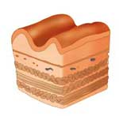
Stomach Wall contains Gastric Glands
Mucus which protects the stomach against damage by the acid
Pepsinogen (inactive)
HCl (acidic environment)
Gastric Juice
Pepsin (active)
Proteins
Peptides
Produce

4. Small intestine
- A tube 5-6 M long
- Divided into duodenum, jejenum, ileum
- Secretes enzymes which help in digestion.
- The ileum contains infolding’s called villi which increase the surface area available for the absorption of food

Basic structure of small intestine in relation to its function:
- 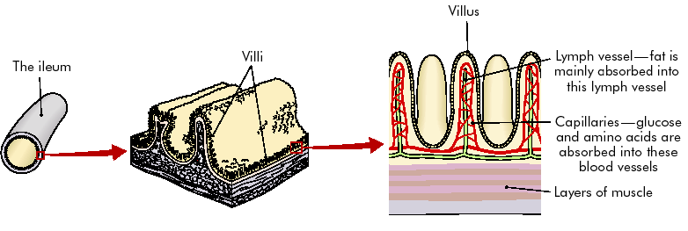Inner lining of small intestine contains many infoldings called villi.
H.P.V.
Lymphatic system.
- Each villus has many microvilli.
- These villi increase the area available for absorption.
- Walls are only one cell thick.
- Rich blood supply.
- Contain blind ending lacteals

Absorption
End products of digestion: Glucose, amino acids, fatty acids and glycerol.
They pass by diffusion into the villi of the ileum.

- Glucose and amino acids absorbed into capillaries and brought via the hepatic portal vein to the liver for assimilation.
- Fatty acids and glycerol are too large to pass into the capillaries.
- They reform to fats and they are absorbed into lacteals (blind ending lymph vessels).
- The fats are transported by the lymph, which carries them to the blood stream.
- They are returned to the blood at the subclavian vein at the base of the neck.

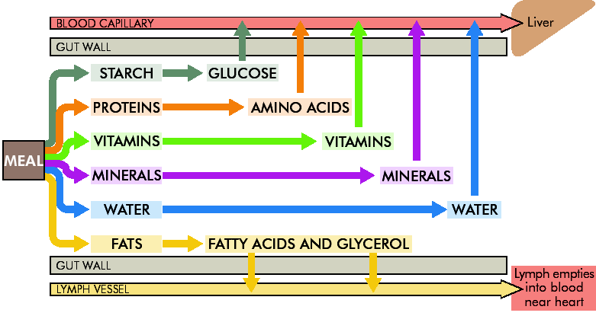
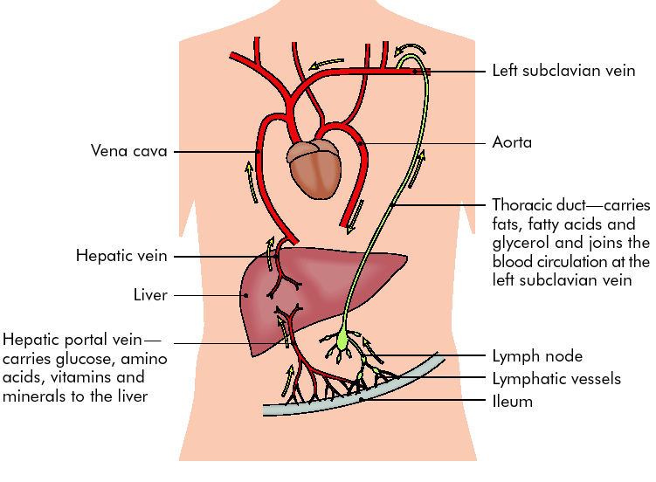

5. Large Intestine
- Colon is about 1 M long
- Functions in the absorption of water
- Contains symbiotic bacteria. These bacteria live in humans and help in digestion. E.g. Bifidobacterium. Lactobacillus,
  - They feed on waste.
  - They produce vitamins B and K
  - They break down cellulose.
- Materials remain for about 12 hours and then moves to the rectum.

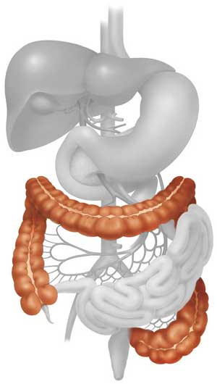
Basic structure of large intestine in relation to its function:

Caecum : Part of intestine below junction with
the large intestine.
Appendix: At end of caecum.

Function of the large intestine:
- Reabsorb water from undigested waste.
- Convert undigested waste into faeces.
- Faeces stored in rectum.
- Egested through anus.
Appendix
Caecum

Benefits of fibre
- Prevents constipation
- Stimulates peristalsis

6. Rectum
- Undigested waste known as faeces is stored in the rectum
- Faeces consists of bacteria, unabsorbed food, cells from the intestine wall, bile pigments and mucus
- Faeces is egested through the anus

7. Liver
- Largest gland in the body
- Functions in the assimilation of digested foods
- Produces bile
- Bile is stored in the gall bladder and secreted into the small intestine

Role of Bile salts
- Liver produces bile – yellow green alkaline fluid.
- Formed from remains of red blood cells
- Bile consists of water, bile salts and bile pigments.
- No enzymes.
- Stored in the gall bladder and released into the small intestine through the bile duct.
- Contains sodium bicarbonate (bile salts) – helps neutralisation of acidic food from stomach
- Bile salts emulsify fats

Functions of bile
- Emulsifies fats which increase the surface area for enzyme digestion (lipase).
- It contains sodium bicarbonate which helps to neutralise chyme from the stomach.

8. Pancreas
- Produces pancreatic juice
- Contains digestive enzymes –Pacreatic amylase, pancreatic protease, pancreatic lipase
- Lipase breaks fats into fatty acids and glycerol
- The pancreas produces the hormone insulin

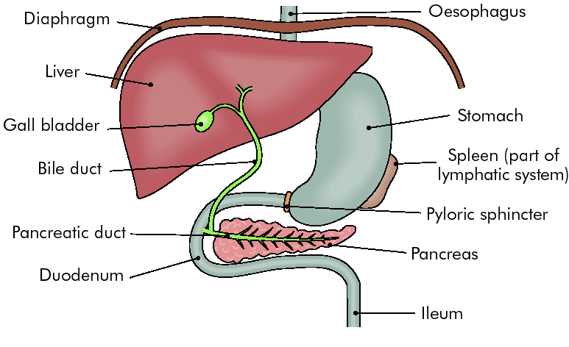

Role, Production site, pH at a named location of action of an amylase, a protease, and a lipase enzyme

Enzyme name | Production site | pH | Location of action | Substrate | Product
Salivary Amylase | Salivary glands | Alkaline  ~ 8 | Mouth | Starch | Maltose
Protease (Pepsin) | Gastric glands | Acid  ~ 2 | Stomach | Proteins | Peptides
Pancreatic Lipase | Pancreas | Alkaline  ~ 8 | Duodenum | Fats | Fatty acids + glycerol

3.3.5 Blood Transport of nutrients (Summary)
Absorption
End products of digestion: Glucose, amino acids and fatty acids and glycerol.

- Glucose and amino acids absorbed into capillaries and brought via the hepatic portal vein to the liver for assimilation.
- Fatty acids and glycerol are too large to pass into the capillaries.
- They reform to fats and they are absorbed into lacteals (blind ending lymph vessels).
- The fats are transported by the lymph, which carries them to the blood stream.
- They are returned to the blood at the subclavian vein at the base of the neck.

Describe the functions of the liver (without detailed biochemical pathways) in list format.
Functions of the Liver:
Assimilation
- Converts glucose to glycogen. Glycogen is stored in the liver and muscle. When energy is required the glycogen is converted to glucose and transported to all nutrient requiring cells of the body.
- Amino acids transported to cells, tissues and organs for growth and repair.
- Breaks down excess proteins to urea. Urea is then transported in the blood to the kidney for excretion.
- Converts excess carbohydrates to fat. Fat is stored under the skin.

Other functions of liver
- Produces bile
- Detoxifies harmful compounds e.g. alcohol
- Stores vitamins and minerals.
- Makes fibrinogen
- Makes cholesterol
- Produces heat

The transport of nutrients from the liver to all nutrient-requiring cells of the body.
The transport of waste products to the kidney for filtration and excretion.

3.3.6 Balanced Human Diet (Summary)
A balanced diet consists of the right amounts of the following components:
- Carbohydrates
- Proteins
- Fats
- Vitamins
- Minerals
- Fibre
- Water
These components should come from a variety of sources as follows:
- milk and milk products;
- meat, fish and poultry;
- breads and cereals;
- fruit and vegetables;
- others, e.g. fats, oils and alcohol
This is in order to ensure that the body gets all the necessary energy and nutrients.
The correct amount of food required by each person depends on age, sex (gender) and activity levels.
The energy content of food is measured in units called joules (J) or kilojoules (kJ) or calories or kilocalories (kcal).
Energy (RDA )
Female (16 yr old girl) = 9,600kJ
Male ( 16 yr old ) = 12,600
Some food facts:

1g carbohydrate = 17kJ energy
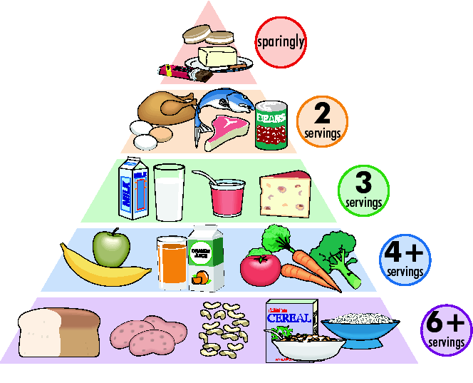
1g protein = 17kJ energy
1g fat = 38kJ

5
Teenagers
Food Pyramid:

