**Q 2016 13**

1. (i) Name the part of the eye that has a corresponding function to the cochlea of the ear. Explain your answer.
2. Light passes through the pupil in the eye.
   1. Name the structure that determines the diameter of the pupil.
   2. Why is there a mechanism for changing the diameter of the pupil?
3. Certain parts of the eye are transparent and have curved surfaces.
   1. Name **two** such parts.
   2. How does the curvature contribute to the functioning of the eye?
4. The eyes of carnivores are located relatively close together at the front of the skull. In herbivores they tend to be located more to the sides of the skull.

Referring clearly to either carnivores **or** herbivores, suggest a benefit of **either** arrangement.

### (24)

**MS 2016 13**

|  |  |  |  |  |  |  |  |  |  |
| --- | --- | --- | --- | --- | --- | --- | --- | --- | --- |
| (c) | (i) | *Corresponding part of eye:* *Retina **or** *fovea | | | | |  |  | **3** |
|  |  | *Why:* Both contain receptors (or both detect stimuli) **or** both generate impulses | | | | | | |  |
|  |  |  |  | **or** both send impulses to the brain | | |  |  | **3** |
|  | (ii) | 1. | *Structure that determines pupil diameter:* *Iris | | | | |  | **3** |
|  |  | 2. | *Why pupil diameter changeable:* To control the amount of light entering the eye **or**  to prevent too much light entering the eye **or** to let more light enter the eye | | | | | | **3** |
|  | (iii) | 1. | *Transparent and curved:* Cornea | | |  |  |  | **3** |
|  |  |  |  | Lens | |  |  |  | **3** |
|  |  | 2. | *How curvature helps eye:* To focus **or** to bend light **or** to refract light | | | | | | **3** |
|  | (iv) | *Carnivores:* Better judgement of distance **or** better focus on prey | | | | | | |  |
|  |  |  |  |  | **OR** | |  |  | **3** |
|  |  | *Herbivores:* Better detection of predators **or** wider field of vision (to detect | | | | | | |  |
|  |  |  |  | predators) |  |  |  |  |  |

**2009 Q 15 b**

(b)

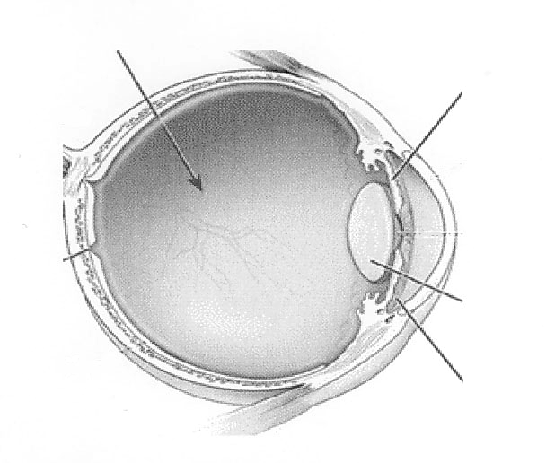

Z

V

Y

X

V

### W

The diagram shows the human eye.

1. Name the parts labelled V, W and X.
2. Give the functions of parts Y and Z.
3. 1.Suspensory ligaments. 2. Cones. 3. Optic nerve. 4. Brain. Outline the roles in vision of any **three** of the above structures.
4. Explain how the iris works.
5. Suggest a reason why two eyes are better than one

**MS 2009 15 b**

