3.4.3 The Structure of an Exchange System in Flowering Plants
Describe the structure of the leaf in relation to gaseous exchange.
Explain the role of lenticels in stem structures
3.4.5 Plant Excretion
Explain the role of leaves and lenticels as excretory organs of plants
H.3.4.7 Carbon Dioxide: a controlling factor in gaseous exchange
Explain how the Carbon dioxide level is a controlling factor in stomatal opening

Summary

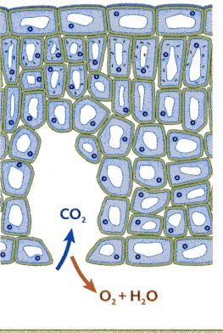
Gaseous exchange in a leaf
Respiration
- Oxygen diffuses from air into the leaf through stomata for respiration
- Carbon dioxide produced in respiration diffuses from leaf through stomata into the air
Photosynthesis
- Carbon dioxide required for photosynthesis diffuses from the air into the leaf through stomata
- Oxygen produced during photosynthesis diffuses from the leaf into the air through the stomata
High levels of CO₂
cause stomata to close

Low levels of CO₂
cause stomata to open

- Gaseous exchange in a stem
- Lenticels are openings in the bark of trees and shrubs that allow gaseous exchange.
- Oxygen diffuses in
- Carbon dioxide and water vapour diffuse out

Excretion is the removal of metabolic waste and is usually referred to in relation to animals. Secretion or loss would be more appropriate in reference to a plant as they do not produce metabolic waste as such.

The leaves and lenticels act as excretory organs through which oxygen, carbon dioxide and water vapour diffuse in and out of the plant

