Name ________________________________

INTERPRETING ECOLOGICAL DATA
Graph 1: Rabbits Over Time  a. The graph shows a __________ growth curve.  b. The carrying capacity for rabbits is ______  c. During which month were the rabbits in exponential growth? | 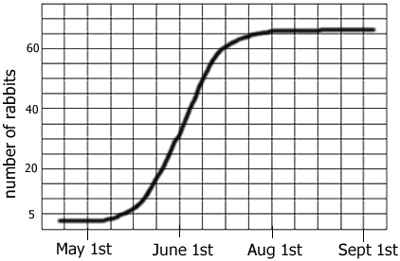
Graph 2: Average Toe Length  a. In 1800, about how many people surveyed had a 3 cm toe? _______  How many in 2000? _______  b. The data shows the ____________ selection has occurred?  c. In 2000, what is the average toe length? ______ What is the average toe length in 1800 _______ | 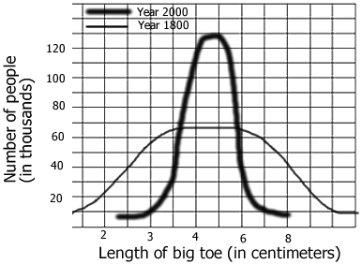
Graph 3: Mexico and US  a. In Mexico, what percentage of the population is between 0-4 years of age? _______ In the US? ______  b. Which population is growing the fastest? ________  c. Which age group has the smallest number in both countries? _____ | 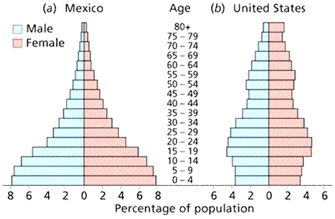
xxxxxxxxxxxxxxxxxxxxxxxxxxxxxxxxxxxxxxxxxxxxxxxxxxxxxxxxxxxxxxxxxxxxxxxxxxxxxxxxxxxxxxxxxxxxxxxxxxxxxxx
Chart 4: Trapping Geese  In order to estimate the population of geese in Northern Wisconsin, ecologists marked 10 geese and then released them back into the population. Over a 6 year period, geese were trapped and their numbers recorded.  a. Use the formula to calculate the estimated number of geese in the area studied? _____________  b. This technique is called ____________ & ______________  c. Supposing more of the geese found in the trap had the mark, would the estimated number of geese in the area be greater or lesser? _____ | Year Geese Trapped Number with Mark  1980 10 1  1981 15 1  1982 12 1  1983 8 0  1984 5 2  1985 10 1  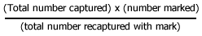
Chart 5: Mushroom Plots  Another ecologist uses a different method to estimate the number of mushrooms in a forest. She plots a 10x10 area and randomly chooses 5 spots, where she counts the number of mushrooms in the plots and records them on the grid.  a.Calculate the number of mushrooms in the forest based on the grid data: _________________  b. Thie technique is called _______________ | 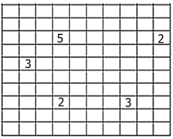

Chart 6: Snakes & Mice  The data shows populations of snake and mice found in an experimental field.  a. During which year was the mouse population at zero population growth? ______  b. What is the carrying capacity for snakes ? ______  c. What is the carrying capacity for mice? _____  d. What is the rate of growth (r) for mice during 1970? _____ During 1980? ______ | Year Snakes Mice born Mice died  1960 2 1000 200  1970 10 800 300  1980 30 400 500  1990 15 600 550  2000 14 620 600  2001 15 640 580

