Learning outcomes: 3.1.1, 3.1.2, 3.1.3 and H.3.1.9,H. 3.1.10  At the end of this section you should be able to … | Y | N
3.1.1 Know the 5 kingdom system of classification :

3.1.2 Know the distribution of bacteria and fungi in nature – salt water, fresh water, terrestrial, air-borne

3.1.3 Draw and describe the basic structure of Bacterial cells
( including plasmid DNA)
3.1.3 Know the 3 main types of bacteria

3.1.3 Describe Reproduction in bacteria

3.1.3 Describe Nutrition in bacteria

3.1.3 Describe the factors affecting growth of bacteria

3.1.3 Explain the term Pathogen

3.1.3 Define and describe the role of antibiotics

3.1.3 Contemporary Issue
Explain the economic importance of bacteria: Give examples of any 2 beneficial and any 2 harmful bacteria

3.1.3 Explain the potential abuse of antibiotics in medicine

H. 3.1.9 Nature of bacteria and fungi
Describe prokaryotic nature of bacteria and eukaryotic nature of fungi

H.L. Contemporary Issue:
H. 3.1.10 Growth curves:
Plot a growth curve to include the 5 phases of growth
Give an explanation of microbial behaviour at each stage.
H. 3.1.10
Describe Batch and continuous flow food processing.

Key Words
Prokaryotic, Eukaryotic, Endospore, Plasmid, Binary fisson, Autotrophic, Heterotrophic, Photosynthetic, Chemosynthetic, Saprophytic, Parasitic, Pathogen, Antibiotic, Batch food processing, Continuous food processing

Bacteria (Summary)
5 kingdoms
Monera (Bacteria) | Prokaryotic
Protista (Amoeba)  Fungi (Mushroom)  Plantae (Oak)  Anamalia (Tiger) | Eukaryotic

Distribution:
Bacteria and fungi are found everywhere – salt water, fresh water, terrestrial, air-borne.
Ubiquitous: found everywhere.

Structure of a bacterial cell
Labels required:
- Cell wall
- Cell membrane
- Genomic material including plasmid
- Cytoplasm
- Flagella
- Capsule

Cell wall
Nuclear (genomic) material
flagella

cytoplasm
Cell membrane
Capsule
Plasmid
Cell wall

3 main types.

- Cocci e.g. streptococcus

- Spirals e.g. Syphilis.

  - Rods e.g. T.B.

Reproduction: Binary fisson
- DNA replicates
- Cell elongates pushing the replicated DNA apart
- Ingrowths of the cell membranes and cell walls occur forming two identical cells or organisms.

Because of their short life cycle and multiple generations, mutations become a very important feature.
Under favourable conditions reproduction can occur once every twenty minutes.
Bacterial growth can be represented by a growth curve

Growth curve (5 Phase)

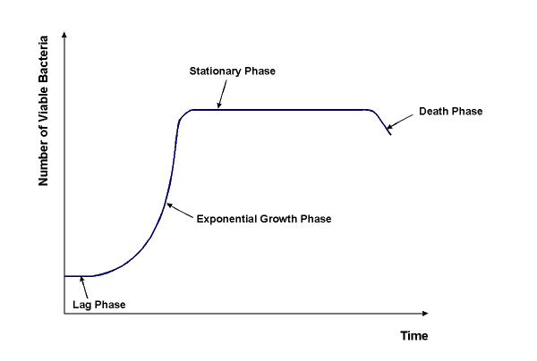
Log
Survival Phase

Lag Phase: Cells adapting to new environment. Cells increase in size but do not divide. No increase in numbers

Log Phase: Cell numbers increase at ever increasing rates with time. The more cells that are present the faster the population of cells increases. Optimum conditions for growth.

Stationary Phase: No increase in numbers. Rate of cell growth is equal to cell death. At this point bacteria are competing for food, space, moisture and oxygen. There is also a build up of toxic wastes.

Decline Phase: Cell death exceeds cell birth. Due to same factors as in stationary phase.

Survival Phase: Many bacteria survive by developing endospores in response to unfavourable conditions. Endospores remain dormant until conditions become suitable.

Endospore Formation:
Formed in unfavourable environments.
- Cell shrinks
- Rounds up
- Forms a thick wall within the original structure.

When conditions become favourable:
- Spores absorb water
- Break their walls
- Reproduce by binary fisson

Factors affecting growth
- Temperature
- Oxygen concentration
- pH
- External solute concentration
- Pressure

Nutrition in bacteria

Autotrophic: Organisms which have the ability to make their own food from inorganic molecules
2 types of autotrophs

- Chemosynthetic: Organisms which make their own food using energy from chemical reactions
- Photosynthetic: Organisms which make their own food using energy from sunlight

Heterotrophic: Organisms which cannot make their own food. Must eat food made by other organisms

2 types of heterotrophs

- Saprophytic: Organisms feed on dead and decaying organic matter
- Parasitic: An organism lives in or on another organism causing it harm.

Economic importance
Beneficial Microorganisms: Streptococcus in yogurt making. Lactobacillus used to make antibiotics
Harmful Microorganisms: Pneumonia caused by Pneumococcus. Cholera caused by vibrio

Pathogenic bacteria
- Bacteria capable of causing disease
Definition of Antibiotics
Compounds produced by microorganisms that stop the growth, or kill other microorganisms.

Role of antibiotics:
Used to treat bacterial infection

Potential abuse due to:
- Over prescription of antibiotics
- Not completing full course of antibiotics
- Taking antibiotics to treat colds and flu (viral infections). Antibiotics only effective against bacterial infections.

Describe Batch and continuous flow food processing.
Batch Culture
Phases of growth: 5 phases
Lag, Log, Stationary, Decline, Survival
Survival Phase

Continuous Culture
Phase of growth: maintained in Exponential

Batch food processing
- Cells are grown in a fixed volume of liquid medium in a closed vessel.

- Nothing added or removed during incubation period.

- Products removed at the end. E.g. yoghurt making

- 5 phase growth rate

Continuous food processing
- Nutrients added and products remooved continuously at a rate that maintains the volume at a fixed level

- e.g. Production of single cell protein

- Continuous growth rate (exponential)

