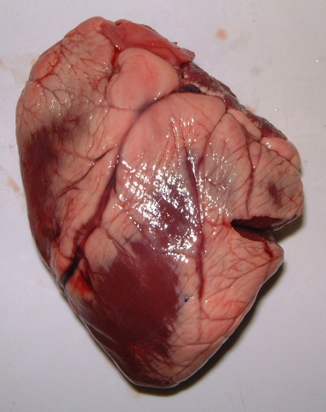

Procedure
- Wash the heart with cold water. Drain and dry it with paper towels.
- Place the heart on the dissecting board/white tray so that the front (ventral) side is facing up.
- The front of the heart is recognised by feeling the sidewalls. The left side will feel much firmer than the right side.
- To further identify the front of the heart observe a groove that extends from the right side of the broad end of the heart diagonally downward. This groove is the location of a coronary vessel. (Fig.l)
- Locate the following chambers of the heart:
left atrium - upper chamber on your right
left ventricle - lower chamber on. your right
right atrium - upper chamber on your left
right ventricle - lower chamber on your left (Fig. 2).
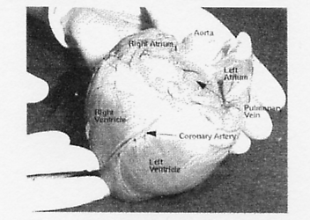

Figure 2 Chambers of the hear
- Note the main blood vessels located at the broad end of the heart.
- Draw a labeled sketch of the external structure of the heart.
- Carefully make a shallow cut in the left ventricle and left atrium following the lines in Fig. 3
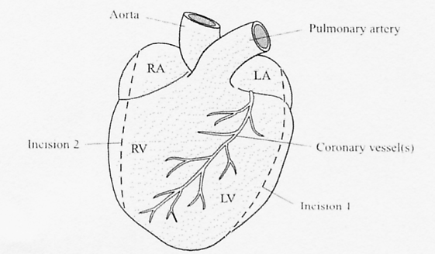

Figure 3 Points of incision

- Using your fingers, push open the heart at the cut to examine the internal structure. If there is blood inside the chambers, rinse out the heart.
- Observe the different sizes of the chambers.
- Locate the bicuspid valve between the left atrium and left ventricle. This valve consists of two flaps.
- Insert the forceps under the chordae tendinae and notice that they extend from the valve, to the papillary muscles.
- Repeat steps 8 to 10 for the other side of the heart.
- Note the difference in thickness between the walls of the left and right ventricles.
- Locate the tricuspid valve between the right atrium and the right ventricle. This valve consists of three flaps.
- Find the septum, a thick muscular wall, which separates the right and ieft venlricies.
- Insert the seeker (or your finger) through the arteries and veins in order to identify them.
- Using the scalpel cut open the aorta and observe the semi-lunar valve. Note the three half-moon shaped flaps of this valve.
- Find two small openings at the base of the aorta just above the semi-lunar valve. These lead into the coronary arteries. Insert the seeker into a coronary artery to trace its pathway.
- Wash and sterilise the dissecting instruments after use.
- Draw a large labelled diagram of the internal structure of the heart.

