Q 2015 11
- (i)  (ii) | Humans are heterotrophic and omnivorous. Explain each of these terms.  What is meant by a balanced diet?
( b) (i) | Draw a large diagram of the human alimentary canal and its associated glands. On your diagram label all of the following:
  - Two associated glands. Name each gland labelled and put the letter G in brackets after each name to indicate it is a gland.

  - Two parts of the small intestine. Name each part labelled and put the letter S in brackets after each name to indicate it is part of the small intestine.

  - Two parts of the large intestine. Name each part labelled and put the letter L in brackets after each name to indicate it is part of the large intestine.

- Answer the following questions in relation to lipase.

  - What is lipase?

  - Give one part of the alimentary canal that secretes lipase.

  - What is the approximate pH at the site of lipase action? (27)

- (i) 1. Write the dental formula for an adult human with a full set of teeth.
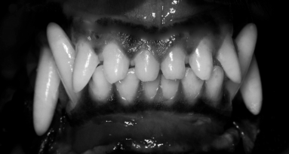
- Give one difference between the dental formula referred to above and the tooth arrangement of the mammal in the photograph below.

- What type of food do you think is mainly consumed by the mammal in the photograph? Explain your answer.

MS 2015 11
- (i) Heterotrophic: must consume food or eats other organisms  or cannot make their food  Omnivorous: eats both animal and plant (material)  (ii) Correct amounts of each food type (for health)  - (i) Diagram: continuous tube + stomach + intestines + a gland |  |  |  | 3  3  3  6, 3, 0
 |  | 1. | Liver / salivary glands / pancreas | 2(2, 1, 0)
 |  | 2. | Duodenum / ileum | 2(2, 1, 0)
 |  | 3. | Colon / caecum (or appendix) / rectum | 2(2, 1, 0)
(b) | (ii) | 1. | Enzyme that digests lipids (or fats or oils) | 3
 |  | 2. | Stomach or duodenum | 3
 |  |  | [accept small intestine or ileum or salivary glands or pancreas]
 |  | 3. | Stomach: (pH) < 7
 |  |  | Duodenum or small intestine or ileum: (pH) 7 – 9 | 3
2 1 2 3  - (i) 1. I C PM M  2 1 2 3  - (Humans have) fewer incisors (or fewer canines)  or Animal shown has more incisors (or more canines)  - Type of food: meat or flesh or other animals  Explanation: long (or sharp or pointed or large or extra) canines (or incisors)  - Absorption of water / peristalsis / egestion / absorb vitamins  - Production of vitamins / compete with other micro-organisms / digestion / benefit immune system |  |  |  | 3  3  3  3  2(3)  2(3)

Q 2012 15 a
  - The diagram shows part of a transverse section through the small intestine.
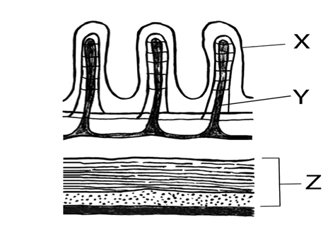

    - Name structures X and Y.

    - What process results from the contraction of the two parts of tissue Z?

    - In your answer book, indicate which of the following most accurately represents the pH of the contents of the small intestine.

Acidic. Neutral. Alkaline.

    - Name two glands that pass their secretions into the small intestine.

    - 1. What are symbiotic bacteria?
2. Give two functions of symbiotic bacteria in the human alimentary canal.

    - Where in the human alimentary canal is most water absorbed?

MS 2012 15 a
15. (a) | (i) | (X =) *Villus | 3
 |  | (Y =) *Lacteal | 3
 | (ii) | *Peristalsis | 3
 | (iii) | *Alkaline | 3
 | (iv) | *Pancreas | 3
 |  | *Liver | 3
 | (v) | - (Bacteria) living on or in another organism involving benefit  - Vitamin production / compete with pathogens / reference to digestion / inhibits cancer cells | 3
 |  |  | 2(3)
 | (vi) | *Colon or *large intestine | 3

Q 2011 5
- (i) What is meant by the term digestion?

- Why is digestion necessary?
- Distinguish between mechanical and chemical digestion by writing a sentence about each.

- The diagram shows part of the human alimentary canal and associated structures.
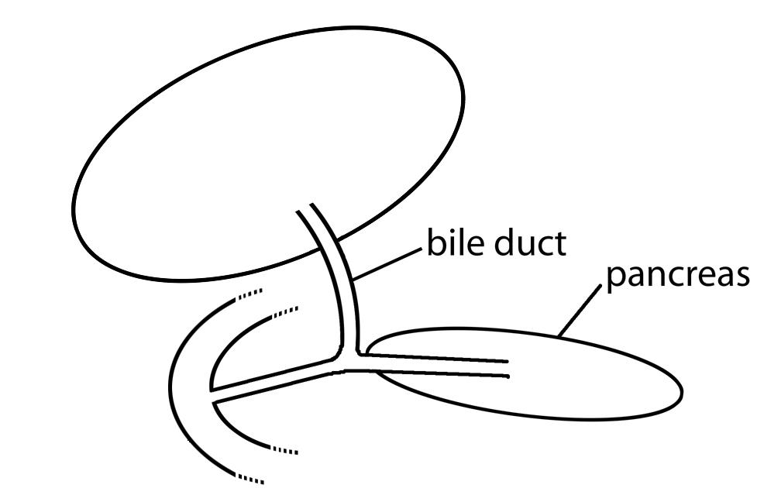
X
W

  - What part of the alimentary canal is labelled W?
  - The bile duct is connected to X. Name X.

  - From which part of the alimentary canal does food arrive into W?

  - State one digestive function of the pancreas.

MS 2011 5
 | (a) | (i) | The breakdown of food
 |  | (ii) | For solubility or for absorption or for transport
 |  | (iii) | Mechanical: physical or grinding or cutting or churning or chewing or emulsifying  Chemical: (action of) enzyme or named enzyme or (action of) acid or named acid
 | (b) | (i) | Duodenum or small intestine
 |  | (ii) | Gall bladder or liver
 |  | (iii) | Stomach
 |  | (iv) | (Produces) enzymes or named enzyme or neutralises (chyme)

Q 2010 15 b
  - Draw a labelled diagram to show the relationship between the liver, the small intestine and the hepatic portal vein.
- Name a substance transported to the liver by the blood in the hepatic portal vein.
- Name the blood vessel that brings oxygenated blood to the liver.
- Where in the human body is the liver located in relation to the stomach?
- Where is bile stored after it has been made in the liver?
- Give one role that the bile salts play in the digestive process.
- Give two further functions of the liver, other than the manufacture of bile.

MS 2010 15 b
(b) | (i) | Diagram (liver, connection, gut)  Labels (liver, intestine and portal vein) | 3, 0  3(2)
 | (ii) | Named food or CO2 | 3
 | (iii) | *Hepatic artery | 3
 | (iv) | Above or to the right or behind | 3
 | (v) | *Gall bladder | 3
 | (vi) | Emulsify fats (or explained) or neutralise (or comment on pH) | 3
 | (vii) | Storage of (fat-soluble) vitamins (or glycogen or named mineral) / deamination / heat generation / detoxification / plasma protein production / cholesterol production  Any two | 2(3)

Q 2008 12

- (a) (i) Distinguish between mechanical and chemical digestion.
(ii) Name a structure in the human digestive system, other than teeth, which is involved in mechanical digestion. (9)

- The diagram shows the human digestive system.
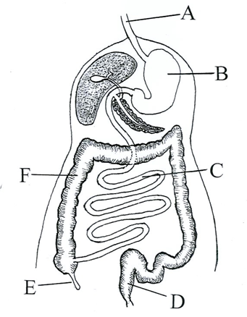

  - Name the parts A, B, C, D, E and F.
  - Describe two functions of bile in relation to digestion.
  - Answer the following in relation to a lipase:
    - Where is it secreted?
    - Where does it act?
    - What is the approximate pH at its site of action? (27)

- (i) What are symbiotic bacteria?
- Give two activities of symbiotic bacteria in the human digestive system.
- Name the part(s) of the digestive system in which the following are absorbed into the blood.
  - the products of digestion,
  - water.
- Name a process involved in the passage of the products of digestion into the blood.
- Explain how the structure that you have named in (iii) 1. is adapted for the absorption of the products of digestion. (24)

MS 2008 12
(a) | (i) | mechanical: | 3
 |  | physical or grinding or cutting or churning or chewing or emulsifying
 |  | chemical:
 |  | enzyme or acidic action or molecular breakdown | 3
 | (ii) | tongue or oesophagus or stomach or small intestine or named part of small intestine | 3
(b) | (i) | A = oesophagus B = stomach C = small intestine or ileum D = rectum E = appendix F = large intestine or colon | 6(2)
 | (ii) | emulsification or explained | 3
 |  | neutralisation or raises pH or makes alkaline | 3
 | (iii) | 1. pancreas [allow duodenum] | 3
 |  | 2. duodenum or small intestine or ileum | 3
 |  | 3. 7 – 9 inclusive | 3
(c) | (i) | (bacteria that) live in (or on) another organism involving benefit | 6
 | (ii) | digestion / production of vitamins / benefit immune system / compete with other micro-organisms [allow one reference to harmful activity] | 2(3)
 | (iii) | 1. ileum or villi [allow duodenum or small intestine] | 3
 |  | 2. Colon [allow any named part from stomach onwards] | 3
 | (iv) | diffusion or passive transport | 3
 | (v) | large surface area (folding) or good blood supply or lymph supply or  (lining) one cell thick or long or villi or microvilli | 3

Q 2006 5
Study the diagram and then answer the following questions.
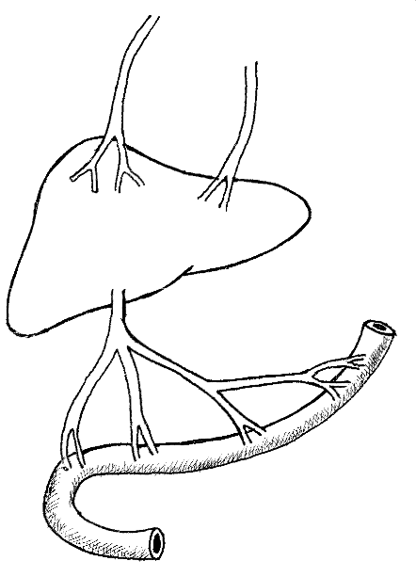
Hepatic Vein
Hepatic Artery
Organ X
Y
Intestine

  - Name X and Y
  - Place arrows on Y, the hepatic artery and the hepatic vein to indicate the direction of blood flow.
  - State the precise location of organ X in the human body
- State a role that organ X plays in the digestive process

MS 2006 5
5. 6(3) + 2
(a) X: liver
Y: (hepatic) portal vein or portal system
(b) Arrow 1 – Arrow 2 – Arrow 3 -
(c) upper abdomen or under diaphragm or correctly related to stomach
(d) (produces) bile or emulsification or (produces) NaHCO3 or neutralizes acid

Q 2005 6

The diagram shows part of a section of the human small intestine.
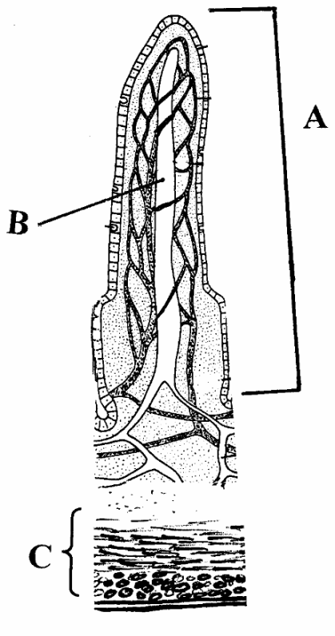

  - Name A, B, C.
  - State two ways in which A is adapted for the absorption of soluble foods.
  - Name a process by which soluble foods are absorbed into the blood from the small intestine.
  - What type of food is mainly absorbed into B?

MS 2005 6

6. | 5(2) + 2(5)
(a) | A = villus B = lacteal or lymph vessel C = muscle or wall
(b) | Large surface area / rich blood supply / microvilli / thin-walled / lacteal | any two
(c) | Diffusion (passive transport)
(d) | Fats / fatty acids /glycerol / lipids | any one

Q 2004 6
- Answer the following questions in relation to the human alimentary canal.
What is peristalsis?
State one reason why a low pH is important in the stomach
Why is fibre important?
Name an enzyme that is involved in the digestion of fat What are the products of fat digestion? What is the role of bile in fat digestion?
State a role of beneficial bacteria in the alimentary canal

MS 2004 6

2(5) + 5(2)
Muscular activity or description e.g. contractions to move food [allow ‘movement of food’] Kills germs or optimal pH for enzymes or hydrolysis of starch or other correct reason Peristalsis or explained (e.g. bulk for movement) [accept reference to constipation or bowel cancer]
Lipase
Fatty acids or glycerol
Emulsification (must imply smaller globules produced) or pH effect or explained Production of vitamins or inhibition of pathogens or (aids) digestion or example

