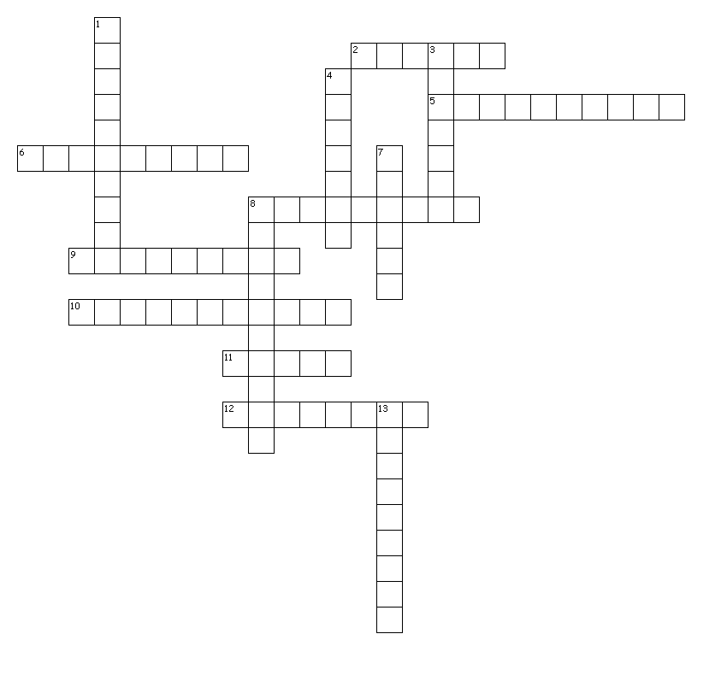**Circulatory System**

**Across**

2. A factor which determines a positive or negative blood group …………….

5. This node sends impulses into walls of ventricles ……….

6. Shape of RBC …….

8. Initiates heart beat …….

9. Second heart sound caused by closing of these valves …….

10. RBC contain this protein …….

11. The fluid in lymph vessels ……

12. Ventricular relaxation …..

**Down**

1. A type of white blood cell ….

3. Ventricular contraction ….

4. A type of cell which clots blood ….

7. Fluid part of blood …

8. Engulfs and destroys …

13. This system collects excess tissue fluid ….

