|  |  |  |
| --- | --- | --- |
| At the end of this section you should be able to …. | Y | N |
| Define metabolism |  |  |
| Refer to solar energy and cellular energy. |  |  |
| Understand the selective permeability of membranes  surrounding the cells and within cells. |  |  |
| Define the terms “diffusion” and “osmosis”. |  |  |
| Give examples of each. |  |  |
| Define “turgor”. |  |  |
| Give a simple explanation of turgidity in plant cells. |  |  |
| **Contemporary Issue**  Describe the application of high salt or sugar concentrations in food preservation |  |  |
| **Practical Activity**  Conduct any activity to demonstrate osmosis |  |  |

**Key words**

**Osmosis, diffusion, active transport, turgor**

**Summary**

* **Metabolism: The sum of all chemical reactions in a cell. (Anabolic and Catabolic)**

**Two main sources of energy:**

1. **Solar energy**

Sunlight is a source of energy capable of being absorbed by cellular pigments e.g. chlorophyll.

1. **Cellular energy**

Cell sources of energy capable of release by metabolic processes in cells

**Selective permeability of cell membranes, surrounding the cells and within cells.**

* Plant and animal cells and their cellular organelles are surrounded by cell membranes which control the passage of substances in and out of a cell.
* All cells require oxygen and food for metabolic activities and these substances must be able to enter into the cell.
* Waste substances produced during these activities must be removed from the cell.
* The cell membrane of plant and animal cells is **selectively permeable** as it allows the passage of some substances into the cell but prevents the passage of others.

**Note:** Cell organelles such as the nucleus, mitochondrian, chloroplast are also surrounded by membranes

Substances enter and leave the cell by:

1. Diffusion
2. Osmosis
3. Active transport
4. **Diffusion:** The movement of substances from an area of high concentration to an area of lower concentration.

Energy is not required to move the substances so diffusion is said to be a **passive** process i.e a substance will diffuse from where it is more concentrated to where it is less concentrated across a membrane until both sides are of equal concentration .

**Example:**

Movement of oxygen and carbon dioxide during gaseous exchange.

O2



CO2

CO2



Cell membrane

Nucleus

**2. Osmosis :** The movement of **water molecules** across a selectively permeable membrane, from an area of **high water concentration** to an area of **lower water concentration,** until both concentrations are equal.

* Osmosis is a a special case of diffusion
* Water will move once there is a difference in concentration on each side of the membrane (concentration gradient)

**Examples:**

* **Osmosis in *Amoeba***

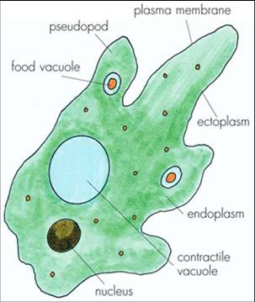

* Why does water continuously enter an amoeba cell?
* How does the amoeba cope with the constant entry of water?
* **Osmosis in Red blood cells – match the text with the diagram**

****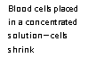

**Blood cells placed in a dil. Solution**

**Cells swell**

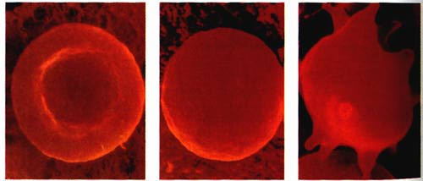

Normal red blood cell

**Turgor**

**Turgor**: The state of a plant cell that has increased to maximum volume due to water intake by osmosis.

* 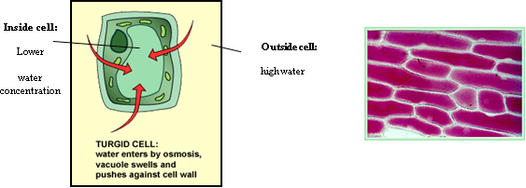**Explanation of how plant cells remain turgid**:

Plant cells contain a cell wall in addition to a cell membrane.

This cell wall is fully permeable.

**If plant cells is placed in pure water (e.g. rain water):**

* Water enters the cell by osmosis
* Cell swells as water enters vacuole
* Vacuole pushes against cytoplasm
* Cytoplasm pushes against cell wall.
* The cell wall pushes back and prevents the cell from bursting.
* The cell is fully turgid (very firm).

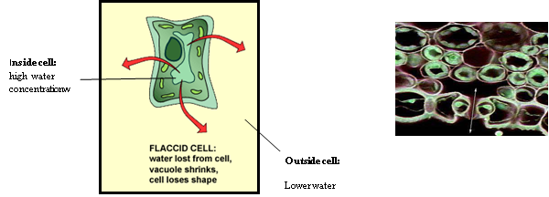

If plant cells contain a less concentrated solution (high water concentration) than their surroundings

* water flows out of vacuole
* the cell shrinks and wilts

**Note:** Turgid is the healthy state for most plant cells. Herbaceous plants (non woody) depend on cells being kept turgid for mechanical support**.**

**Contemporary Issue**

**Food preservation**

The knowledge of the process of osmosis can be used in food preservation.

Examples:

**Jam-making:** High level of sugar draws water from the cells of micro-organisms and they die.

**Salting meat:** High level of salt draws water from the cells of micro-organisms and they die.

**CONDUCT ANY ACTIVITY TO DEMONSTRATE OSMOSIS**

**Procedure**

1. I softened 2 strips of visking tubing by soaking them in water.
2. I tied a knot at one end of each strip.
3. I half-filled one piece of tubing with the sucrose solution and the other with distilled water **(Control**).
4. I eliminated air from the tubes and tie a knot at the open end.
5. I washed off any sucrose solution from the outside of the tubes and dried.
6. I recorded the turgidity of each tube.
7. I recorded the mass of each tube .
8. I suspended each tube in a beaker of distilled water.
9. After 20 min I removed the tubes and dried.
10. I recorded the turgidity of each tube.
11. I recorded the mass of each tube .

12. I repeated the investigation.

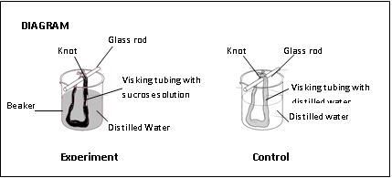

**Results**

|  |  |  |  |  |
| --- | --- | --- | --- | --- |
| **Tube contents** | **Turgidity at start** | **Turgidity after test period** | **Mass at start (g)** | **Mass after test period (g)** |
| **Sucrose solution** | **No** | **Yes** | **10** | **40** |
| **Distilled**  **water** | **No** | **No** | **10** | **10** |