Learning outcomes:
At the end of this section you should be able to ……. |  | Y | N
Explain the terms “cell continuity” and “chromosome”
Define “Haploid” and “Diploid” number
Describe cell activities in the state of
non division (interphase) and division (mitosis)
 | Define cancer and give two possible causes.
 | Define “Mitosis”
 | Simple treatment of mitosis with the aid of diagrams.
 | H.L. Detailed study of the stages of Mitosis with the aid of diagrams,
 | Give the primary function of mitosis in single-celled and multicellular organisms
 | Definition of Meiosis
 | Functions of “meiosis”

Key words
Cell continuity, mitosis, meiosis, interphase, cell cycle, haploid, diploid, prophase, metaphase, anaphase, telophase

Cell Continuity Summary
Cell Continuity: Cells arise from pre-existing cells.
Chromosome: A thread-like structure found in the nuclei of dividing cells, composed of a super-coiled arrangement of DNA and protein.
Haploid cell: A cell which contains one of every chromosome type
Diploid cell: A cell which contains two of each type of chromosome

Cell cycle:
The cell cycle describes a cells state of non-division (interphase) and division (mitosis).
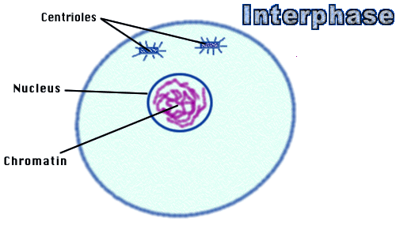
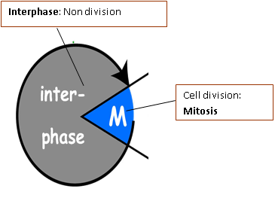
Interphase:
- Cell prepares for mitosis:
- DNA replicates

Note: Chromosomes not visible during interphase (chromatin)
MITOSIS
Mitosis: A form of cell division that produces 2 daughter cells, genetically identical to each other and to the parent cell
Stages of Mitosis

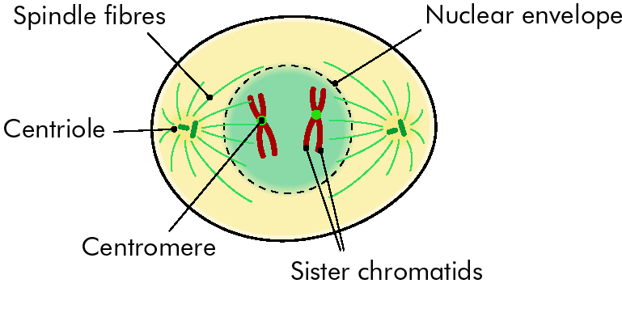
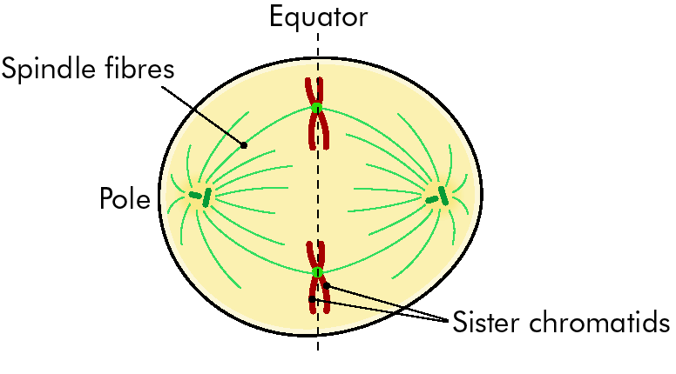

Metaphase
Recognised by
- Presence of a fully formed spindle apparatus
- Chromosome located at equator of cell.

Prophase
Recognised by
- The presence of condensed chromosomes,
- Disappearance of nuclear membrane
- Formation of spindle.

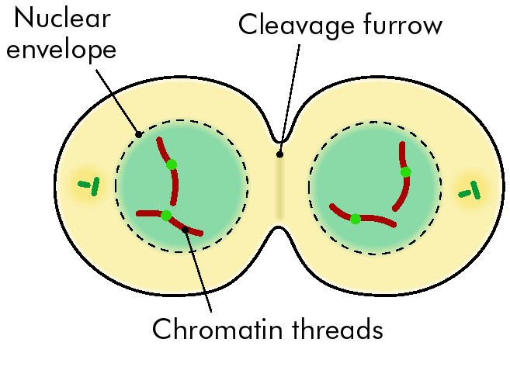
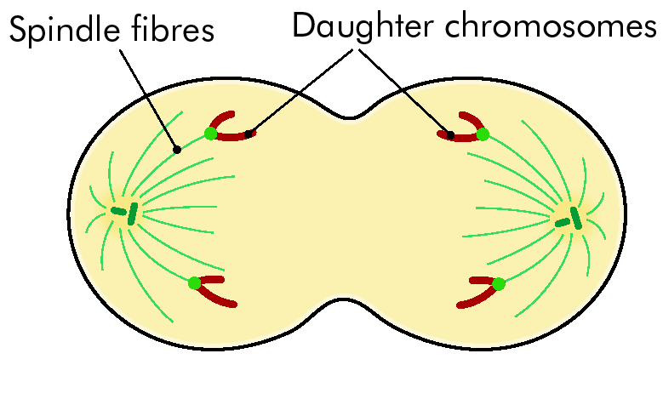

Telophase
Recognised by
- Chromosomes are positioned within new nuclei.
- Cleavage furrow formation in animal cells (see below)
- Cell plate formation in plant cells. (see below)

Anaphase
Recognised by
- Centromeres split,
- Chromosomes pulled back to each end of the cell

Cleavage furrow formation in animal cells,

Cell plate formation in plant cells.

Cell plate
(new wall forms)

Function of Mitosis:
In single-celled organisms: asexual reproduction.
In multicellular organisms: growth and repair.

Cancer
Cancer: Uncontrolled growth of cells.

2 possible causes
1. Carcinogens e.g. tobacco smoke, u.v. light, arsenic
2. Viruses
Hepatitis C virus can cause liver cancer
3. Genetic predisposition
e.g. possession of certain genes increases the risk of certain cancers e.g. BRCA increases risk of breast cancer

Meiosis
Meiosis: A form of cell division that produces
4 genetically different daughter cells,
each of which has half the number of chromosomes
of the parent cell

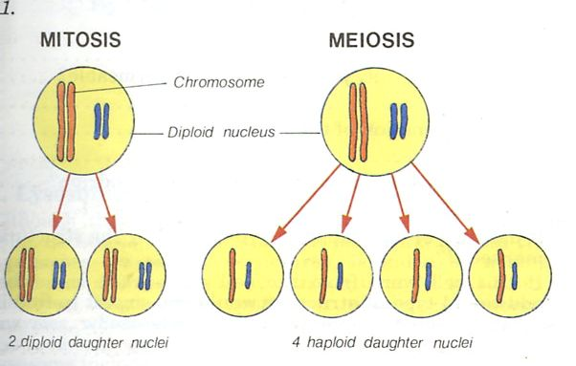
Function of Meiosis:
Sexual reproduction: (formation of haploid sex cells (gametes)

Comparison of Mitosis and Meiosis

