**2.1.1- H. 2.1.4** **Microscopy/Cell Structure and Function/Cell Ultrastructure**

**Learning outcomes** At the end of this section you should be able to ……

|  |  |
| --- | --- |
| Y | N |
| Give a general introduction to the microscope. |  |  |
| Refer specifically to the light microscope and the transmission electron microscope. |  |  |
| **Mandatory Practical Activity:**  Be familiar with and use the light microscope |  |  |
| Give the components of the cell as seen under the light microscope and their functions:  **Plant cells**: cell wall, cytoplasm, nucleus, vacuole and chloroplast.  **Animal cells:** cytoplasm and nucleus. |  |  |
| Indicate the position and function of the cell membrane in a:  Plant cell and Animal cell. |  |  |
|  |  |
| **Mandatory Activity**  Prepare and examine one animal cell and one plant cell (e.g. own cheek cells, onion cells, Elodea leaf, potato tissue, and moss) unstained and stained using the light microscope (x100, x400) |  |  |
| Identify and give the function of the cell membrane, mitochondrion, chloroplast, nucleus, nuclear pores, ribosome, DNA |  |  |

**Key Words (Microscope)**

**Microscope, Stage, Iris diaphragm, Coarse focus, Fine focus, Magnification, Objective lens,**

**Key Words (Cell):**

**Cell, Cell membrane, Cell wall, Organelle, Mitochondrion, Chloroplast, Ribosome, Nucleus, Nuclear pore, Vacuole, DNA, Prokaryotic, Eukaryotic**

**Microscopy Summary**

**2 types of microscope:**

* **Light – uses light to view specimens**
* **Electron – uses electrons to view specimens**

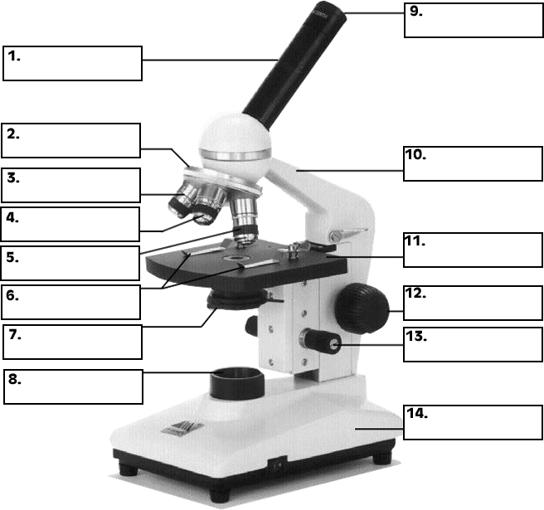**LIGHT MICROSCOPE**

|  |  |
| --- | --- |
| **PART** | **FUNCTION** |
| **Eyepiece** | **Magnifies the image** |
| **Coarse adjustment wheel** | **Rough focusing** |
| **Fine adjustment wheel** | **Precise focusing** |
| **Rotating nosepiece** | **Revolves to move the desired lens into position** |
| **Objective lens** | **Magnifies the image** |
| **Clips** | **Holds the slide in place** |
| **Stage** | **Area on which slide is placed** |
| **Iris diaphragm** | **Controls the amount of light reaching the object** |
| **Light source** | **Supplies light to the object** |
| **Stage height adjustment** | **To change the height between the lens and the stage** |

**BE FAMILIAR WITH AND USE THE LIGHT MICROSCOPE**

**Procedure**

1. I switched on the **light source**.
2. I rotated the **nosepiece** so that the low power lens was used.
3. I put a prepared microscope slide on the stage of the microscope above the hole.
4. I used the **stage clips** to hold the slide in place.
5. I used the **coarse adjustment wheel**, to ensure that the low power lens is at the closest setting to the slide.
6. I looked down the **eyepiece** and adjusted the **iris diaphragm** for correct illumination.
7. I used the **coarse adjustment wheel** to focus the object as sharply as possible and then used the **fine adjustment wheel** to sharpen the focus.
8. I repeated steps 6-7 using the other objective lenses.
9. I drew diagrams of my observations under L.P. and H.P.

Cell:

* All living things are made up of cells.
* The cell is the basic structural and functional unit in an organism.

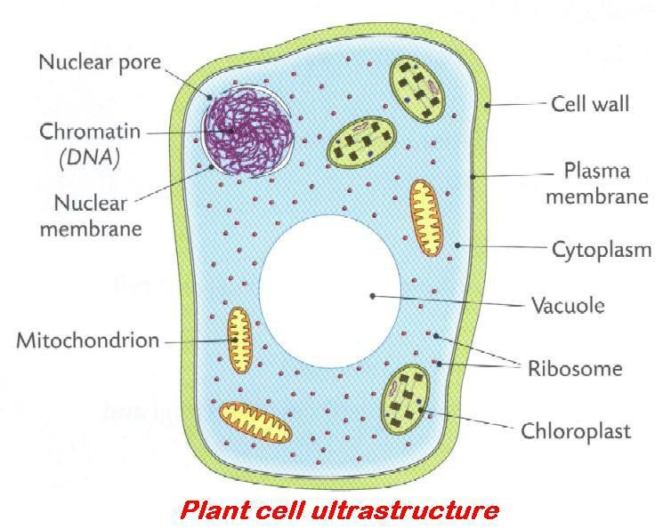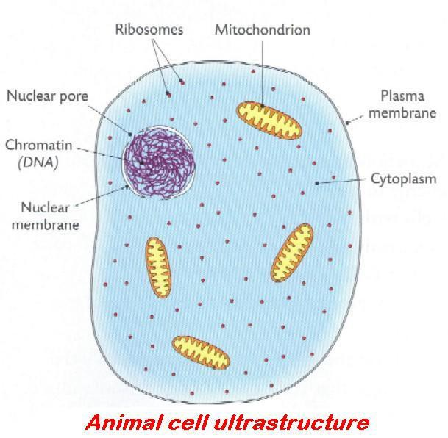

Organelle: a structure in a cell specialised to perform particular specific function, e.g. Cell membrane, Nucleus, Mitochondria, Chloroplast, Ribosomes, DNA, Cell Wall, Vacuole.

|  |  |  |
| --- | --- | --- |
| **COMPONENT/**  **Organelle** | **COMPOSITION** | **FUNCTION** |
| Cell Wall | Cellulose | Gives shape and strength |
| Cell Membrane | phospholipid and protein | Controls the passage of substances in and out of the cell |
| Cytoplasm | Viscous liquid mostly water | Components of cell suspended |
| Nucleus | Nuclear membrane containing chromosomes | Control centre of the cell. |
| Vacuole | Cell sap | Stores water and salts.  Gives cell strength and shape. |
| Chloroplast | Double membrane containing chlorophyll. | Photosynthesis |

|  |  |  |  |
| --- | --- | --- | --- |
| **Component/organelle** | **Composition** | | **Function** |
| Mitochondrian | Double membrane | Respiration | |
| Nuclear pores | Pores | Controls the movement of substances in and out of the nucleus | |
| Ribosome | RNA and protein | Manufactures protein | |
| http://www.google.ie/images?q=tbn:ANd9GcQIH5GzgyYxxwLpEif4-swXF83fpazR2DIIvpw1CqyMoCQ_Fl4yiWnFdADNA | Deoxyribonucleic acid | Unit of inheritance | |

**Prokaryotic cell:**

A cell without a membrane bound nucleus

**Eukaryotic** **cell**

A cell with a membrane bound nucleus

PREPARE AND EXAMINE ONE ANIMAL CELL (i) UNSTAINED AND (ii) STAINED USING THE LIGHT MICROSCOPE (X100, X400)

1. UNSTAINED ANIMAL CELL

PROCEDURE

1. I set up the microscope.
2. I swabbed the inside of my cheek surface and transferred the sample to the slide
3. I covered the sample with a drop of water.
4. I applied the coverslip as follows:
5. I placed the coverslip at the edge of the water at an angle of 450 to the slide.
6. I lowered the coverslip onto the water, supporting it with a mounted needle, until it was in place. This helps to avoid trapping air bubbles.
7. I examined the slide and I drew labelled diagrams of what I saw under x100 and at x400.

http://shs.westport.k12.ct.us/mjvl/biology/microscope/wm2.gif

1 Applying a coverslip

1. STAINED ANIMAL CELL

PROCEDURE



1. I swabbed my inside cheek surface and transferred the sample onto a second slide.
2. I covered the sample with one drop of methylene blue solution.
3. I allowed it to stand for one minute.
4. Using a wash bottle, I washed excess stain from the slide.
5. I applied a cover slip.
6. I examined it under the microscope and drew labelled diagrams

of what I saw at x100 and at x400.

PREPARE AND EXAMINE ONE PLANT CELL (i) UNSTAINED AND (ii) STAINED USING THE LIGHT MICROSCOPE (X100, X400)

1. UNSTAINED PLANT CELL

PROCEDURE

1. I set up the microscope.
2. I cut the onion and located the epidermis.
3. I cut the epidermis into small pieces and put these pieces into water.
4. I transferred one piece into the drop of water on the slide.
5. I applied the cover slip.
6. I examined the slide under the microscope and I drew labelled diagrams

of what I saw at x100 and x400

1. STAINED PLANT CELL

PROCEDURE

1. I set up the microscope.

2. I cut the onion and located the epidermis.

3. I cut the epidermis into small pieces and placed them in water.

4. I transferred one piece onto a slide.

5. I applied a coverslip.

6. I applied the stain as follows:

I placed a drop of iodine solution at one end

of the cover slip and drew it across the plant tissue

by placing the edge of the filter paper at the opposite side of the cover slip.

1. I examined the slide under the microscope and I drew labelled diagrams

of what I saw at x100 and x400

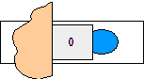

Filter paper

Stain

Applying iodine stain to a plant cell