Name:_______________________________________Date___________

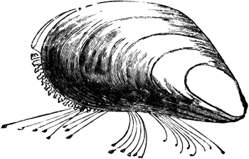Are zebra mussels really invading?
The zebra mussel is a native of the Caspian and Black Seas region and was introduced through ballast water to the Shannon Estuary in the 1990s. Zebra mussels live in freshwater and in the upper reaches of tidal estuaries.
Zebra mussels are widespread in Ireland and continue to be found in new locations
They have spread from this area, principally via boat movements, throughout the Shannon and Shannon-Erne catchments. The zebra mussel can reproduce in less than a year, and a single female can release 1 million eggs each year. These are carried in water currents and settle out after approximately three weeks. They are filter feeders and remove much of the plankton that juvenile fish depend upon. Hence, they may cause an imbalance in fish communities.
In the absence of their natural pathogens, parasites, and predators, the zebra mussel populations in Irish waterways has grown enormously They attach to hard surfaces such as boats, buoys and water intake pipes, where they form very dense clusters. As such, they can cause problems by blocking intake pipes and clogging cooling systems. The mussels are spread from one body of water to another by natural flow, carried on the feathers or feet of migrating waterfowl, or by human transport in bait buckets or on trailered boats. The zebra mussels grow in massive colonies, where nearly a half million individuals may grow on each square meter of substrate. These colonies encrust the hulls and rudders of ships, the hinges of lock gates, and block the drains and intake ducts used by industries and power stations.
The zebra mussels also have severe negative effects on the local ecosystem. As filter-feeders, they take in water and filter out algae as food, excreting their waste as sediment. A single individual can filter 1 liter of water each day, and a colony covering 1 square meter of substrate can filter 180 million liters of water per year. Enormous colonies of zebra mussels can reduce the algal populations of lakes and rivers, thus removing a significant portion of the base of the food chain and resulting in a decline in the fish populations. Thus, these mussels are a threat to the local biodiversity.
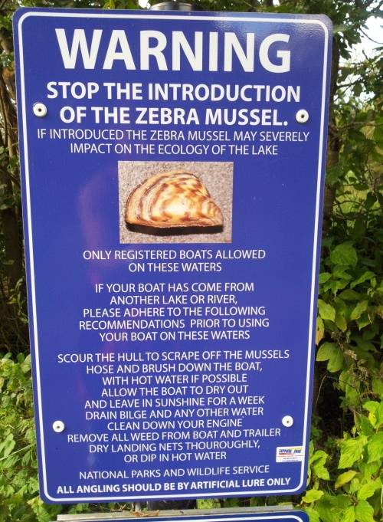The tremendous filtering capacity of these organisms may have some positive consequences. Zebra mussels could be used to clean lakes pollution from fertilizers and sewage.. If these organisms could be controlled, they may become a useful tool in the treatment of sewage and pollution. (Adapted from: Bush, Mark B. 1997. Ecology of a Changing Planet. Prentice Hall, Upper Saddle River, N.J.)

Sign in Killarney National park warning about zebra mussels

Answer the following:
1. What do zebra mussels eat?
a. algae
b. fish
c. insects
d. water plants
2. How might zebra mussels be used to improve lake systems?
a. they can be grown as food for humans
b. they can be used to strengthen dams and levies
c. they clean the water of pollutants
d. they remove algae from the water
3. Zebra mussels can move from one lake to another by which method?
a. on the feet of birds
b. carried by the wind
c. moving overland for short periods
d. swimming up canal systems
4. Massive colonies of zebra mussels cause problems because:
a. they destroy the engines of boats
b. they block the flow of water through ducts
c. they produce waste that pollutes the water
d. they eat large amounts of fish
4. Which of the following is a consequence of the zebra mussel population in lakes
a. cleaner water
b. decline in algae populations
c. decline in fish populations
d. all of these

