2.3.1 Cell Continuity and Chromosome
Explanation of the term “cell continuity” and “chromosome”
Syllabus P. 21
Explanation of the term “cell continuity” and “chromosome”
T.G. P 36

NOTES:

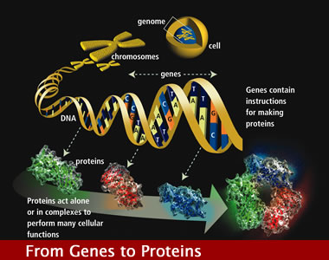

Chromosome 21
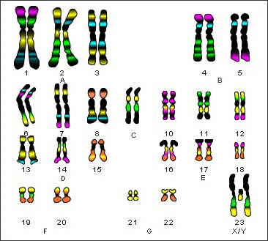
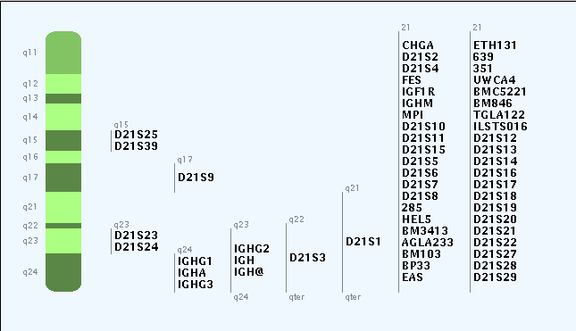

Cell continuity :
- Involves growth, synthesis and reproduction. It can be summarised in a cycle called the “cell cycle”
- The ability of cells to divide and survive from one generation to the next.
- The cell cycle describes a cells state of non-division (interphase) and division (mitosis).

Diagram of Cell Cycle

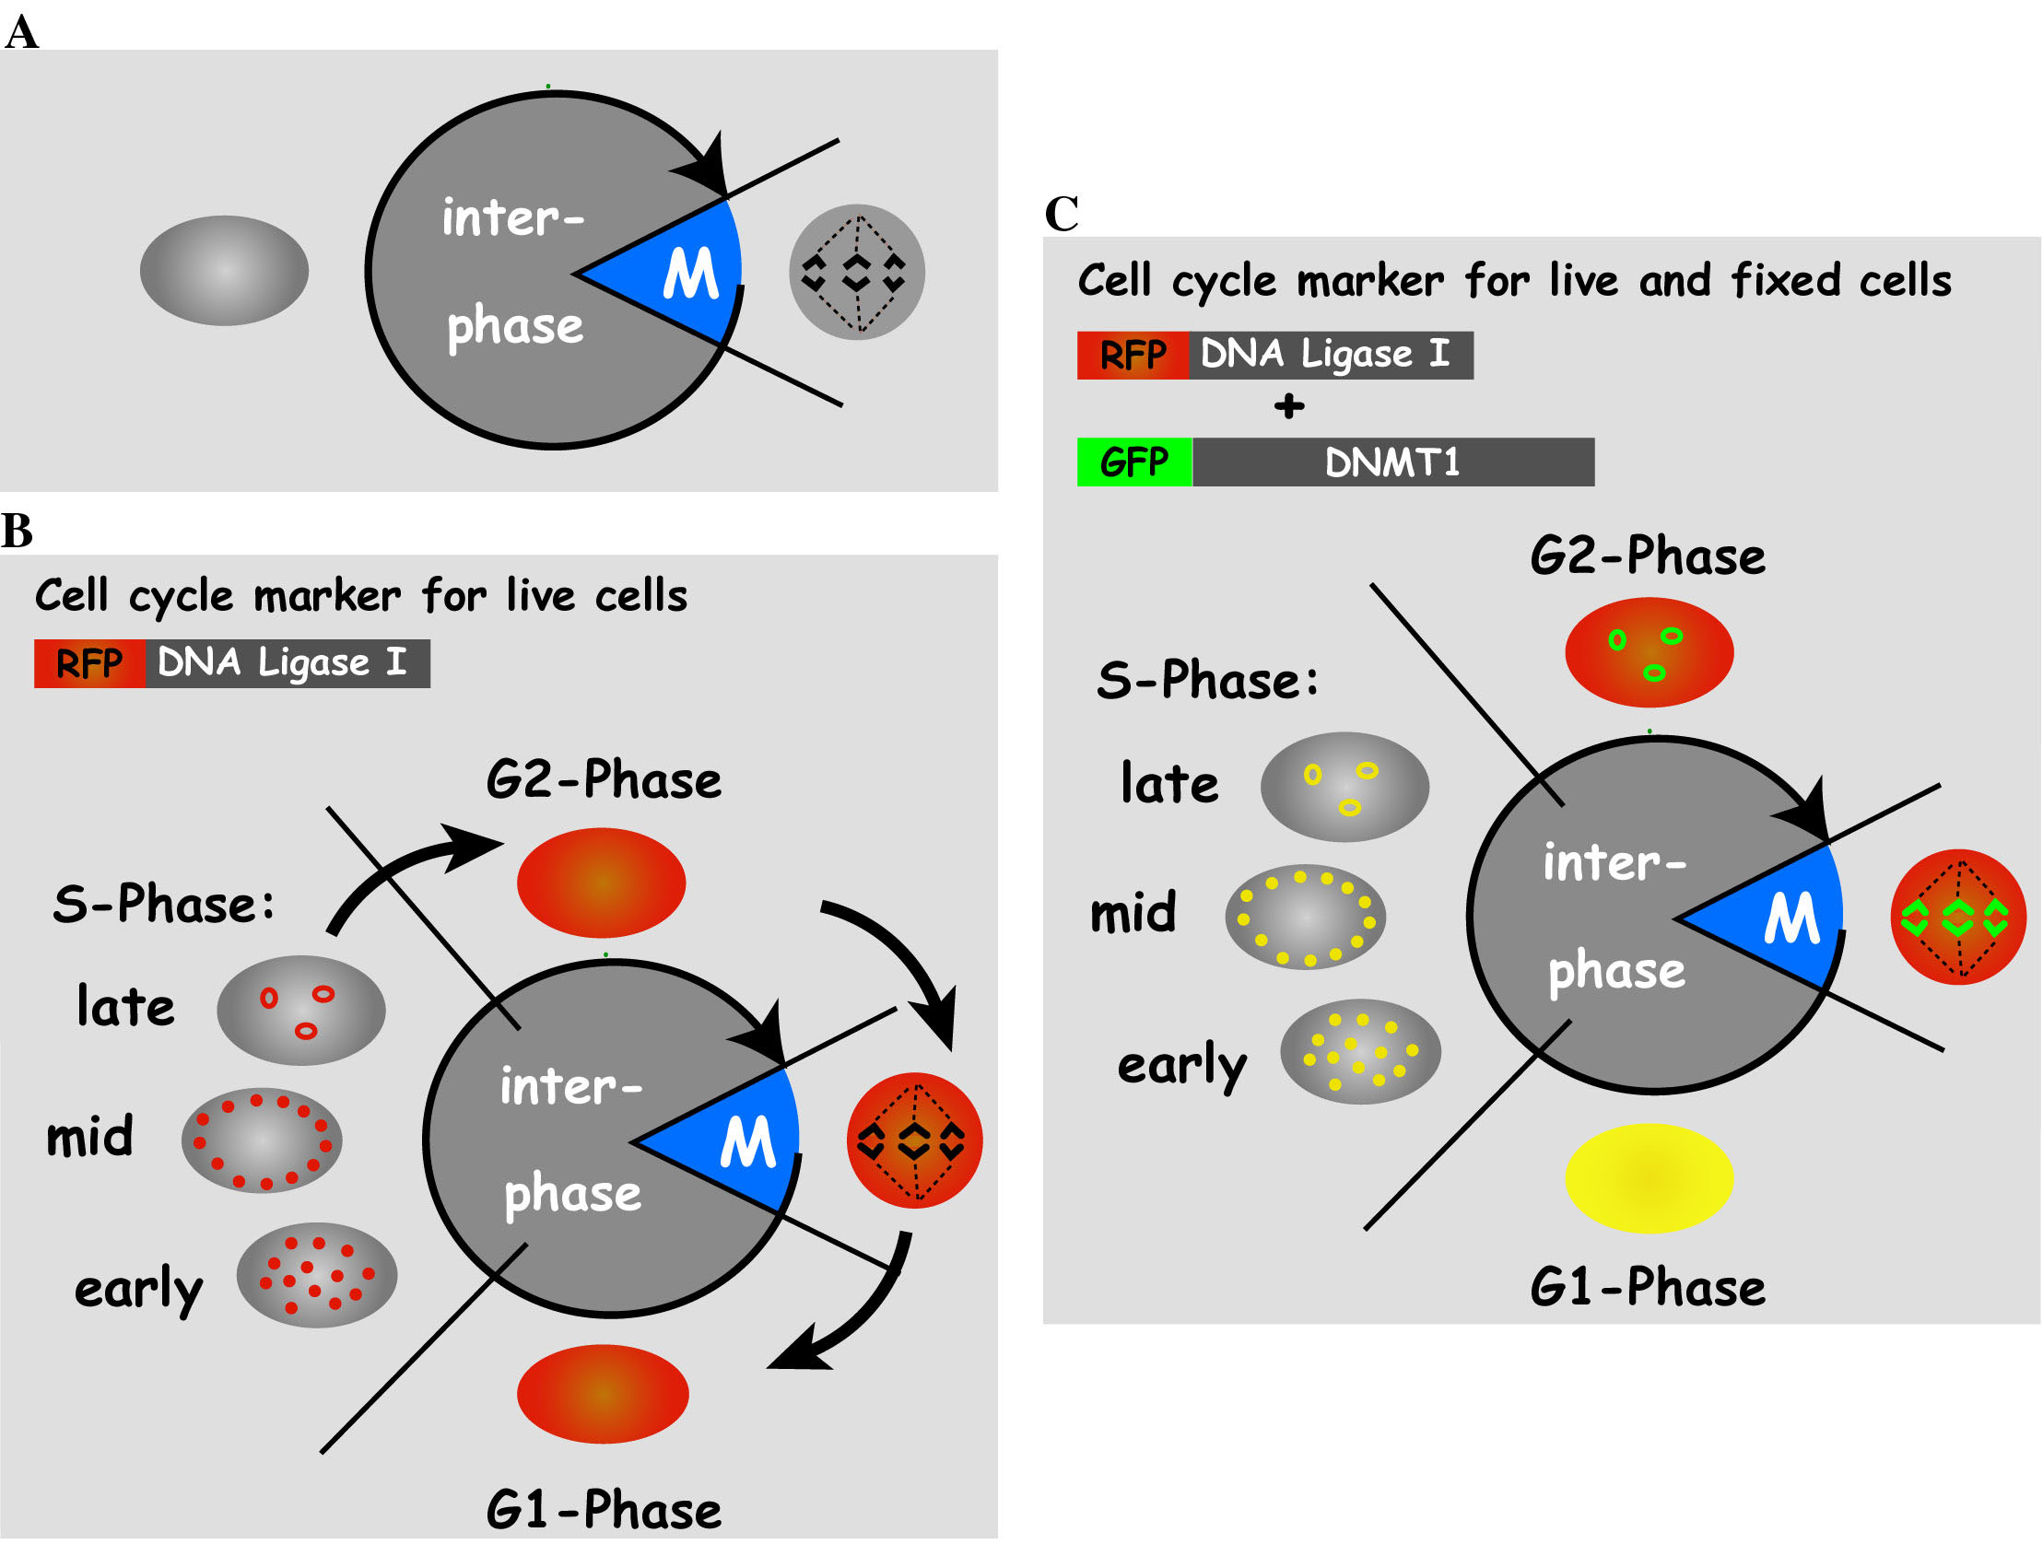

Chromosome
- Thread of DNA
- Wrapped around proteins
- Supercoiled

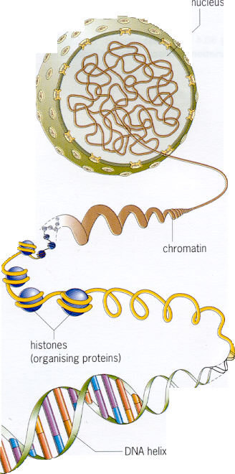


chromosome

2.3.2 Haploid, Diploid
Definition of “Haploid” and “Diploid” number
Syllabus P 21
Definition of
“Haploid number”
and
“Diploid number”
T.G. P. 36

NOTES
Haploid Number: A single set of chromosomes. Half the number of chromosomes present in a diploid cell.

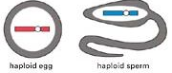

Diploid number: Two sets of chromosomes. Twice the haploid number.

In humans
All body (somatic) cells are diploid i.e. 2n = 46.
Sex cells are haploid i.e. sex cells n = 23

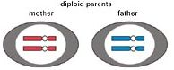

2.3.3 The Cell Cycle
Description of cell activities in the state of non division (interphase) and division (mitosis)
Syllabus: P21
Contemporary Issue
Cancer – definition and two possible causes.
The cell cycle describes the cells activities in the state of non division (interphase) and division (mitosis)
T.G. P. 37

Cancer
A group of disorders in which certain cells lose normal regulation over both the mitotic rate and the number of cell divisions they undergo. This results in uncontrolled multiplication of the abnormal cells.

NOTES
The cell cycle describes the cells activities in the state of non division (interphase) and division (mitosis).

Diagram
Interphase: Non division
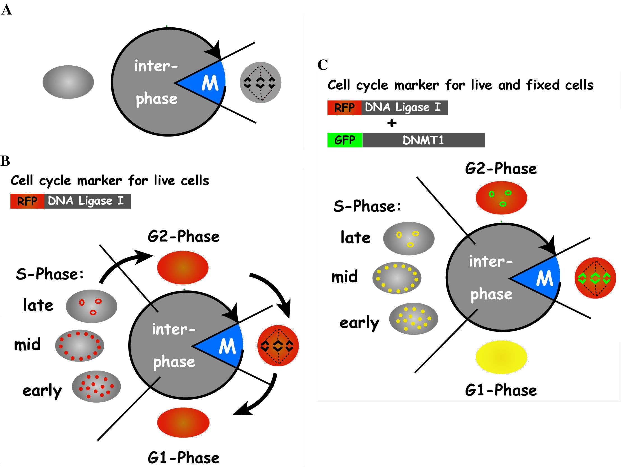

Cell division: Mitosis

Contemporary Issue
Cancer – definition and two possible causes.

Definition

Uncontrolled growth of cells.

A group of disorders in which certain cells lose normal regulation over both the mitotic rate and the number of cell divisions they undergo. This results in uncontrolled multiplication of the abnormal cells.

- In normal cells cell division is kept in control by two types of genes:
- Proto-oncogenes stimulate cell division.
- Tumour suppressor genes inhibit cell division.
- In a healthy cell the activity of these two types of genes are in balance.
- Carcinogens cause Proto-oncogenes to mutate into oncogenes causing cells
to excessively divide resulting in tumours.
- Most tumours are benign.
- Most tumour cells destroyed by the body.
- Tumours which spread through the body are called malignant tumours.
- Malignant tumour cells can be carried by the blood stream or lymphatic
system to invade other tissues, causing secondary cancers.

2 possible causes
1. Carcinogens
Any factor in the environment which causes cancer is a carcinogen. Carcinogens damage DNA.
Examples:
- Chemicals: mercury, arsenic, asbestos.
- Radiation: u.v. light,
- Tobacco smoke

2. Viruses
Hepatitis C virus can cause liver cancer

3. Genetic predisposition

Treatment:
- Surgical removal of tumour
- Radiotherapy
- Chemotherapy

2.3.4 Mitosis
Definition of “Mitosis”
Simple treatment with the aid of diagrams.
(Names of stages and of chromosome parts are not required)
Syllabus P. 21
Definition of “Mitosis”
Simple treatment with the aid of diagrams to show chromosome behaviour.
(Names of stages and of chromosome parts are not required)
Just before the cell divides, chromosomes become visible in the nucleus (short, thick and duplicated).
The nuclear membrane disappears and fibres are formed to which the chromosomes attach. Chromosomes are pulled apart to opposite ends of the cell. A nuclear membrane forms around each set of chromosomes and the cell divides in two. Each new daughter cell now contains the same number of chromosomes as the parent cell.
T.G. P. 37

NOTES
Definition of Mitosis:
A form of cell replication in which the chromosome number remains constant in each of two identical cells generated from one.

During mitosis, the genetic material divides and the cytoplasm organelles and biomolecules are divided into two cells.
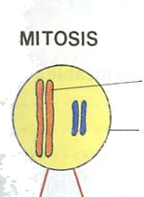

Chromosome

Diploid Parent Cell 2N

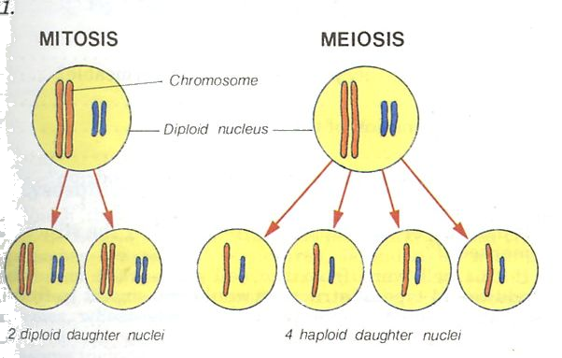

2 diploid daughter cells

2N
2N
Simple treatment with the aid of diagrams to show chromosome behaviour.
(Names of stages and of chromosome parts are not required)
- Just before the cell divides, chromosomes become visible in the nucleus (short, thick and duplicated).
- The nuclear membrane disappears
- Fibres are formed to which the chromosomes attach.
- Chromosomes are pulled apart to opposite ends of the cell.
- A nuclear membrane forms around each set of chromosomes and
the cell divides in two.
- Each new daughter cell now contains the same number of chromosomes as the parent cell.

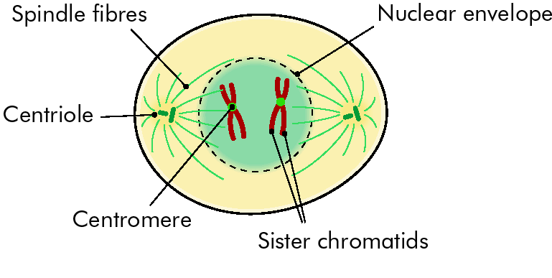
- Just before the cell divides, chromosomes become visible in the nucleus (short, thick and duplicated).

- The nuclear membrane disappears

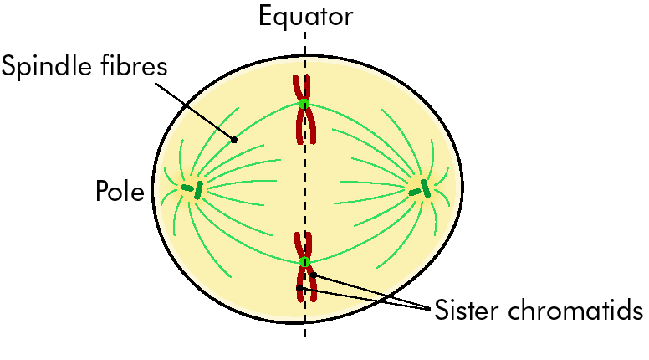

- Fibres are formed to which the chromosomes attach.

Chromosomes

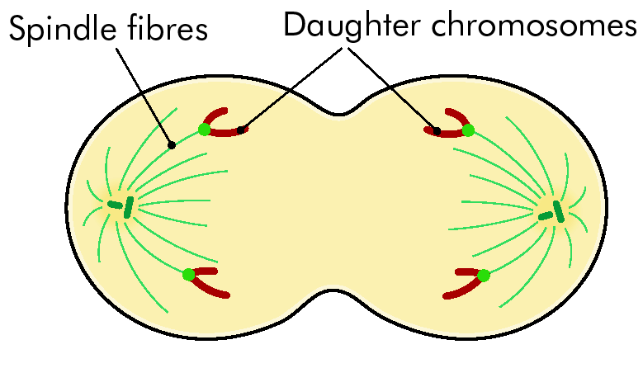

- Chromosomes are pulled apart to opposite ends of the cell.

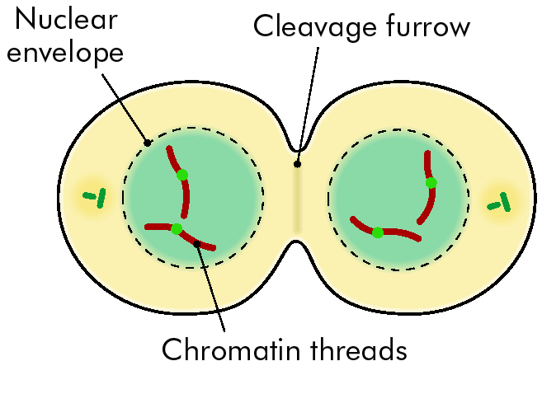
- A nuclear membrane forms around each set of chromosomes

- The cell divides in two.

Chromosome

- Each new daughter cell now contains the same number of chromosomes as the parent cell.

Chromosome

Summary of stages of Mitosis

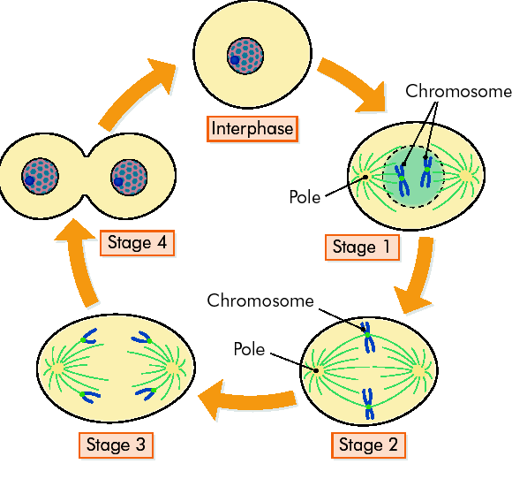

Chromosome

2.3.5 Functions of Mitosis
Primary function in single-celled and multicellular organisms.
Syllabus P. 21
In single-celled organisms, mitosis allows the organism to multiply
In multicellular organisms, mitosis is primarily for growth.
T.G. P. 37

NOTES
Functions of Mitosis

- In single-celled organisms, mitotic division allows the organism to multiply/reproduce.
- In multicellular organisms, mitosis is primarily for growth and repair.

2.3.6 Meiosis

Definition of Meiosis
Syllabus P. 21

Definition of Meiosis
T.G. P. 37

NOTES
Definition of Meiosis
- A form of cell division associated with reproduction
- Halves the chromosome number to form parental half cells (n), sex cells or gametes.

Diagram of Meiosis
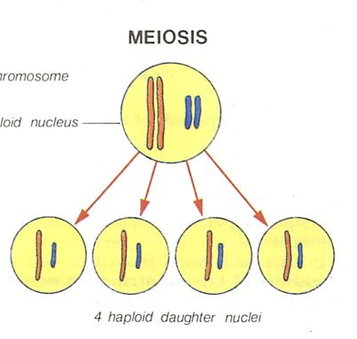

2N Parent cell

Comparison of Mitosis and Meiosis
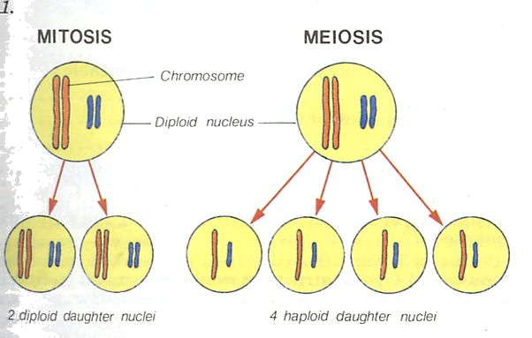

2.3.7 Functions of Meiosis
Functions of “meiosis”
Syllabus P 21

Functions of meiosis in multicellular organisms:
To maintain parental chromosome number by gamete or haploid cell production in sexual reproduction
To introduce variation in the species by re-arrangement of genetic material.
T.G. P 38

NOTES
Functions of meiosis in multicellular organisms:
- Production of gametes (animals) or spores (plants)
- To introduce variation in the species by re-arrangement of genetic material.

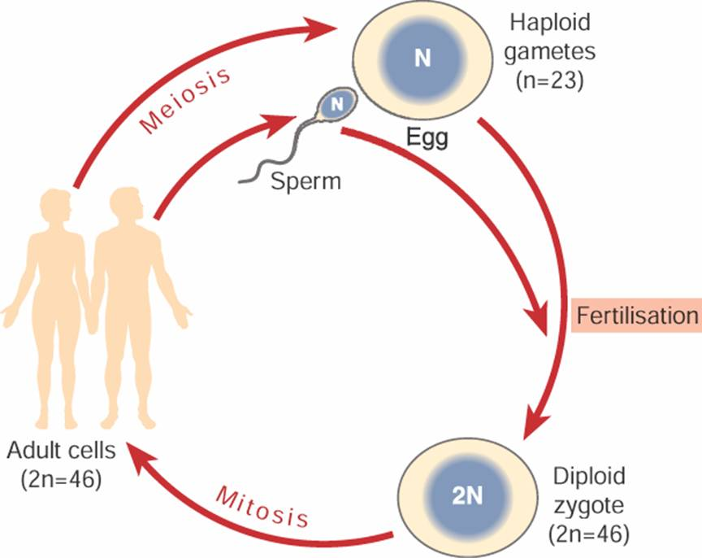

H.2.3.8. Stages of Mitosis (Extended Study)

Detailed study with the aid of diagrams, of the stages of mitosis

Detailed study with the aid of diagrams, of the stages of mitosis
Prophase
Recognised by the presence of condensed chromosomes, disappearance of nuclear membrane and formation of spindle.
Metaphase
Presence of a fully formed spindle apparatus with chromosome located at equator of cell.
Anaphase
Centromeres split, chromosomes pulled back to each end of the cell
Telophase
Chromosomes are positioned within new nuclei. Cleavage furrow formation in animal cells, cell plate formation in plant cells.
T.G. P. 38

NOTES
Detailed study with the aid of diagrams, of the stages of mitosis
The process of Mitosis, a continuous process, is arbitrarily divided into 4 stages for convenience of description.
Prophase
Recognised by the presence of condensed chromosomes, disappearance of nuclear membrane and formation of spindle.
Metaphase
Presence of a fully formed spindle apparatus with chromosome located at equator of cell.
Anaphase
Centromeres split, chromosomes pulled back to each end of the cell
Telophase
Chromosomes are positioned within new nuclei.
Cleavage furrow formation in animal cells,
Cell plate formation in plant cells.

Diagrams showing stages of Mitosis

Prophase
Recognised by
- The presence of condensed chromosomes,
- Disappearance of nuclear membrane
- Formation of spindle.

Metaphase
Recognised by
- Presence of a fully formed spindle apparatus
- Chromosome located at equator of cell.

Anaphase
Recognised by
- Centromeres split,
- Chromosomes pulled back to each end of the cell

Telophase
Recognised by
- Chromosomes are positioned within new nuclei.
- Cleavage furrow formation in animal cells,
- Cell plate formation in plant cells.

Cleavage furrow formation in animal cells,
Cell plate formation in plant cells.

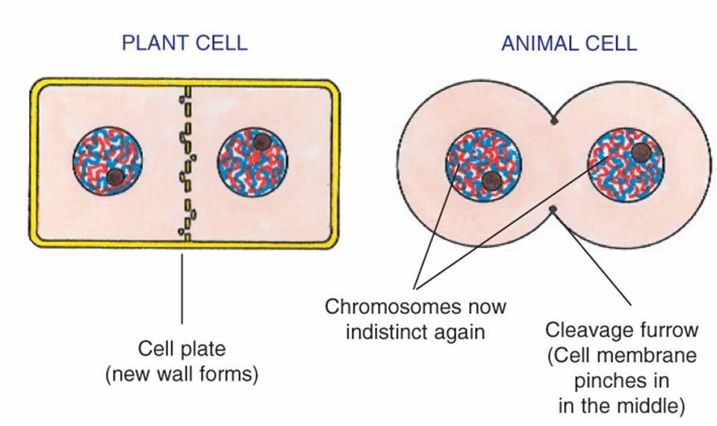
Cell plate
(new wall forms)

Summary of Stages of Mitosis



