1.1 Scientific method
Learning Outcomes:
At the end of this sub section you should be able to: …..
- State the process of the Scientific Method Including Observation, Hypothesis, Experiment, Collect & Interpret Data, Conclusions
- Differentiate between Theory & Principle
- State the limitations of value of the Scientific Method including extent of basic knowledge, basis of investigation, application to the natural world in a state of change, accidental discovery.

Key words
Hypothesis: An educated guess/ a possible explanation for an observation
Control: Set up for comparison with experiment
Data: Measurements/ Observations/ Information gathered during experiment
Replicate: A repeat of an experiment
Theory: A supported hypothesis.
Principle: When a theory has stood the test of time and is shown to be valid under all conditions it may be given the term principle

Summary
Steps involved
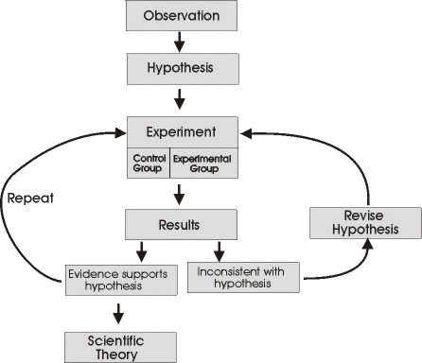
Repeat: Replicate the experiment
Data: Information gathered during experiment
Collect data
Control: Set up for comparison with experiment

Theory: A supported hypothesis
Hypothesis: A possible explanation for an observation
A theory which has stood the test of time may be termed a Principle

Limitations of the Scientific Method
- The extent of our basic knowledge
A basic amount of knowledge is required if the correct questions and hypotheses are to be formed.
- The basis of investigation
Investigations must be carefully and properly designed or the validity of the results will be called into question.
- Our ability to interpret results
Human error or bias on the part of the researcher can lead to incorrect interpretation of results.
- The natural world in a state of change
Theories and hypotheses often do not stand the test of time as new knowledge becomes available and living things are in a constant state of change.
- Accidental discovery
e.g. discovery of DNA profiling, discovery of antibiotics

Observation
Hypothesis
Experiment
Result
Conclusion
If hypothesis is supported
Formation of
Theory and Principle
If hypothesis is not supported
A new hypothesis needs to be found and tested

